

Welcome to PAMS
Handbook
Contents
Welcome to PAMS Handbook 1
Welcome from the Board, CEO and Executive Management Team 5
About Puntukurnu Aboriginal Medical Service (PAMS) 5
What is an Aboriginal Community Controlled Health Organisation (ACCHO)? 5
ACCHS Model of Care 7
We exist to: 7
The Pilbara Aboriginal Health Alliance (PAHA) 7
Aboriginal Health Council of Western Australia (AHCWA) 8
National Aboriginal Community Controlled Health Organisation (NACCHO) 8
PAMS Commitment, Vision and Mission, Workplace and Values 9
Our Cultural Commitment 9
Our Vision 9
Our Mission 9
Our Workplace 9
Core Values 9
Board Composition 10
Executive Management Team Contact Details 13
Members Organisational Chart 16
ACCHO Organisational Chart 17
History of Puntukurnu (Martu - for the people) Aboriginal Medical Service 18
Meet the Martu (Mardu) People History 19
Meet the Nyiyaparli (Nee-Ya-Par-Li) People 21
Community Background 22
Cultural Sensitivity 23
Avoidance Relationships 23
Sorry Time and Lore (cultural traditions) 23
Cultural Traditions 23
Arriving in Newman and Working with PAMS 25
Arriving in Newman: 25
Transit Accommodation (by PAMS) 25
First couple of days in Newman 25
Mail Plane (Remote Community Travel) 25
Considerations before Travelling to Communities 25
Our Clinic Locations and Distances 27
PAMS Newman Clinic 28
Visiting specialists for PAMS Clinics 29
Dialysis Centre 29
Staffing 29
Corporate Services 30
Community Health Programs and Family Health Team 32
Remote Clinics Overview: Jigalong, Parnngurr, Punmu & Kunawarritji 35
Each clinic profile outlines: 36
Jigalong Clinic 37
General 37
Permits 37
Travelling to Jigalong 37
Mail plane to Jigalong 37
Dr’s Charter 37
Vehicles on site 37
Accommodation 38
Map of Jigalong 1 39
Map of Jigalong 2 40
Parnngurr (also known as Cotton Creek) Clinic 41
General 41
Permits 41
Travelling to Parnngurr 41
Mail plane to Parnngurr 41
Staffing 41
Vehicles 42
Accommodation 42
Map of Parnngurr 1 44
Map of Parnngurr 2 45
Punmu Clinic 46
General 46
Permits 46
Travelling to Punmu 46
Mail plane to Punmu 46
Staffing 46
Vehicles 46
Accommodation 47
Map of Punmu 1 48
Map of Punmu 2 49
Kunawarritji (also known as Well 33) Clinic 50
General 50
Permits 50
Travelling to Kunawarritji 50
Mail plane to Jigalong 50
Staffing 50
Vehicles 50
Accommodation 51
Map of Kunawarritji 1 52
Map of Kunawarritji 2 53

Welcome from the Board,
CEO and Executive Management Team
On behalf of the Board of Puntukurnu (Martu for the people) Aboriginal Medical Service, we would like to welcome you to the Pilbara and hope that you enjoy your time working with us.
PAMS is committed to fostering a supportive workplace that values the unique contributions and talents of all of its team members. The culture of the Martu and Nyiyaparli people still runs strongly within the Newman and Western Desert region and makes our communities a unique place to live and work. We are committed to ensuring all staff receive a thorough induction and orientation process and welcome any feedback you may want to provide.
The PAMS management team runs an ‘open door’ policy so at any time should you require support, assistance or even just for debrief please do not hesitate to contact your line manager.
The Pilbara is a unique and beautiful place to live and work and we hope you will love it as much as we do.
- The Board, CEO and Executive Management Team

About Puntukurnu Aboriginal Medical Service (PAMS)
The Puntukurnu Aboriginal Medical Service (PAMS) is an Aboriginal Community Controlled Health Service based in the East Pilbara region of Western Australia. Established in 1994, PAMS serves the Martu and Nyiyaparli peoples across communities including Newman, Jigalong, Parnngurr, Punmu, and Kunawarritji, delivering culturally safe, holistic primary healthcare services.

What is an Aboriginal Community Controlled Health Organisation (ACCHO)?
“An Aboriginal Community Controlled Health Organisation (ACCHO) is a primary health care service initiated and operated by the local Aboriginal community to deliver holistic, comprehensive, and culturally appropriate health care to the community which controls it (through a locally elected Board of Management” - NACCHO 2019
https://www.naccho.org.au/acchos/

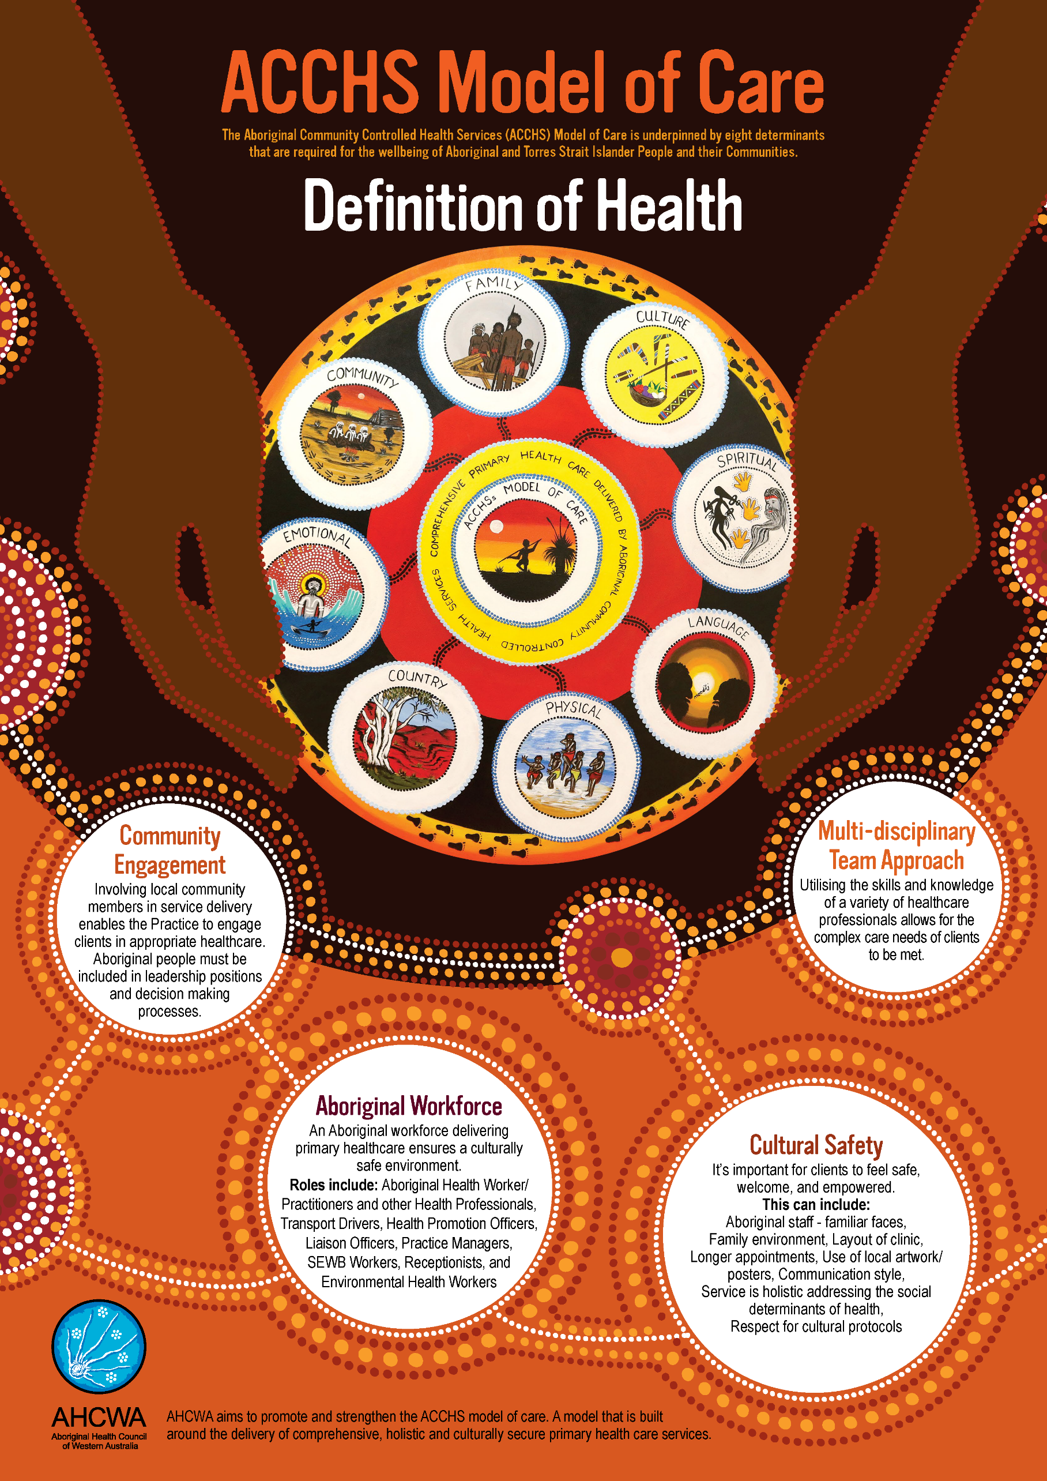
ACCHS Model of Care

We exist to:
Empower | Build the capacity of Aboriginal communities to design and deliver holistic and culturally appropriate health care
Promote Collaboration | Encourage partnerships between WA ACCHS and key stakeholders
Advocate | Provide a voice for the ACCHS sector on key issues that impact the health and wellbeing of Aboriginal people and their communities
Provide Leadership | Enable Aboriginal community leaders to inspire their people to achieve their individual and collective goals and aspirations

The Pilbara Aboriginal Health Alliance (PAHA)
The Pilbara Aboriginal Health Alliance (PAHA) is a partnership between the three Aboriginal Community Controlled Health Organisations (ACCHO’s) based in the Pilbara region of WA, namely, Mawarnkarra Health Service; Wirraka Maya Health Service Aboriginal Corporation; and Puntukurnu Aboriginal Medical Service (Member ACCHO’s ).
The Pilbara Aboriginal Health Alliance (PAHA) works tirelessly alongside its member medical services to open up access to vital healthcare for Aboriginal people in the Pilbara. PAHA and its three Aboriginal medical service members impact people, families and community every day, connecting them with whole-of-life health services that support their physical, social, emotional and cultural wellbeing in new and effective ways.
Together, we represent a powerful alliance – a unified voice that stands for health equity, solutions and strong cultural leadership.

Aboriginal Health Council of Western Australia (AHCWA)
The Aboriginal Health Council of Western Australia is the leading authority for Aboriginal health in Western Australia. They exist to support and act on behalf of the 23 Member Aboriginal Community Controlled Health Services (ACCHS) across the state, offering support, advocacy, and influence; building capacity, and strengthening the Sector to improve health outcomes for Aboriginal people and their communities.

National Aboriginal Community Controlled Health Organisation (NACCHO)
NACCHO is the national peak body representing 146 Aboriginal Community Controlled Health Organisations (ACCHOs) across the country. These ACCHOs are community-run primary healthcare services that provide culturally informed, holistic care to Aboriginal and Torres Strait Islander people. NACCHO's mission is to support these organizations in delivering comprehensive health services, including physical, social, emotional, and cultural wellbeing, to their communities. They play a crucial role in addressing health disparities and promoting self-determination in Indigenous health care.

PAMS Commitment, Vision and Mission,
Workplace and Values

Our Cultural Commitment
We strive in our engagements and services to be culturally responsive and appropriate.

Our Vision
Our Vision is to be the most effective provider of Aboriginal and Torres Strait Islander’s health care and wellbeing through: Supporting and promoting holistic healing of the community, by the community, for the community for present and future generations.

Our Mission
To provide innovative and culturally responsive holistic health care to all in the region.

Our Workplace
We are Collaborative, Accountable and Respectful.

Core Values
We are Community Focussed
We are Community Controlled
We are Transparent
We are Inclusive
We are Leaders

Board Composition
A Board of Directors providing the organisation with strategic and cultural leadership governs Puntukurnu Aboriginal Medical Service.
The Board of Directors are chosen by each community council and is comprised of one male and one female representative from each community of Jigalong Parnngurr, Punmu, Kunawarritji and Newman. https://www.puntukurnu.com.au/
The board is further supplemented with two independent directors who compliment with their expert knowledge in Governance and Public Health.
COMMUNITY | DIRECTOR
Newman | - Stanley Watson (Chairperson)  - Marquisha Slater-Hall
Jigalong | - Jason Crusoe  - Janelle Booth
Parnngurr | - Murphy Williams  - Raelene Butt
Punmu | - Milton Chapman  - Raylene Robinson
Kunawarritji | - Lawrence Whyoulter  - Desray Wilberforce
Independent Directors | - Stephen Klomp  - Dr. Bret Hart

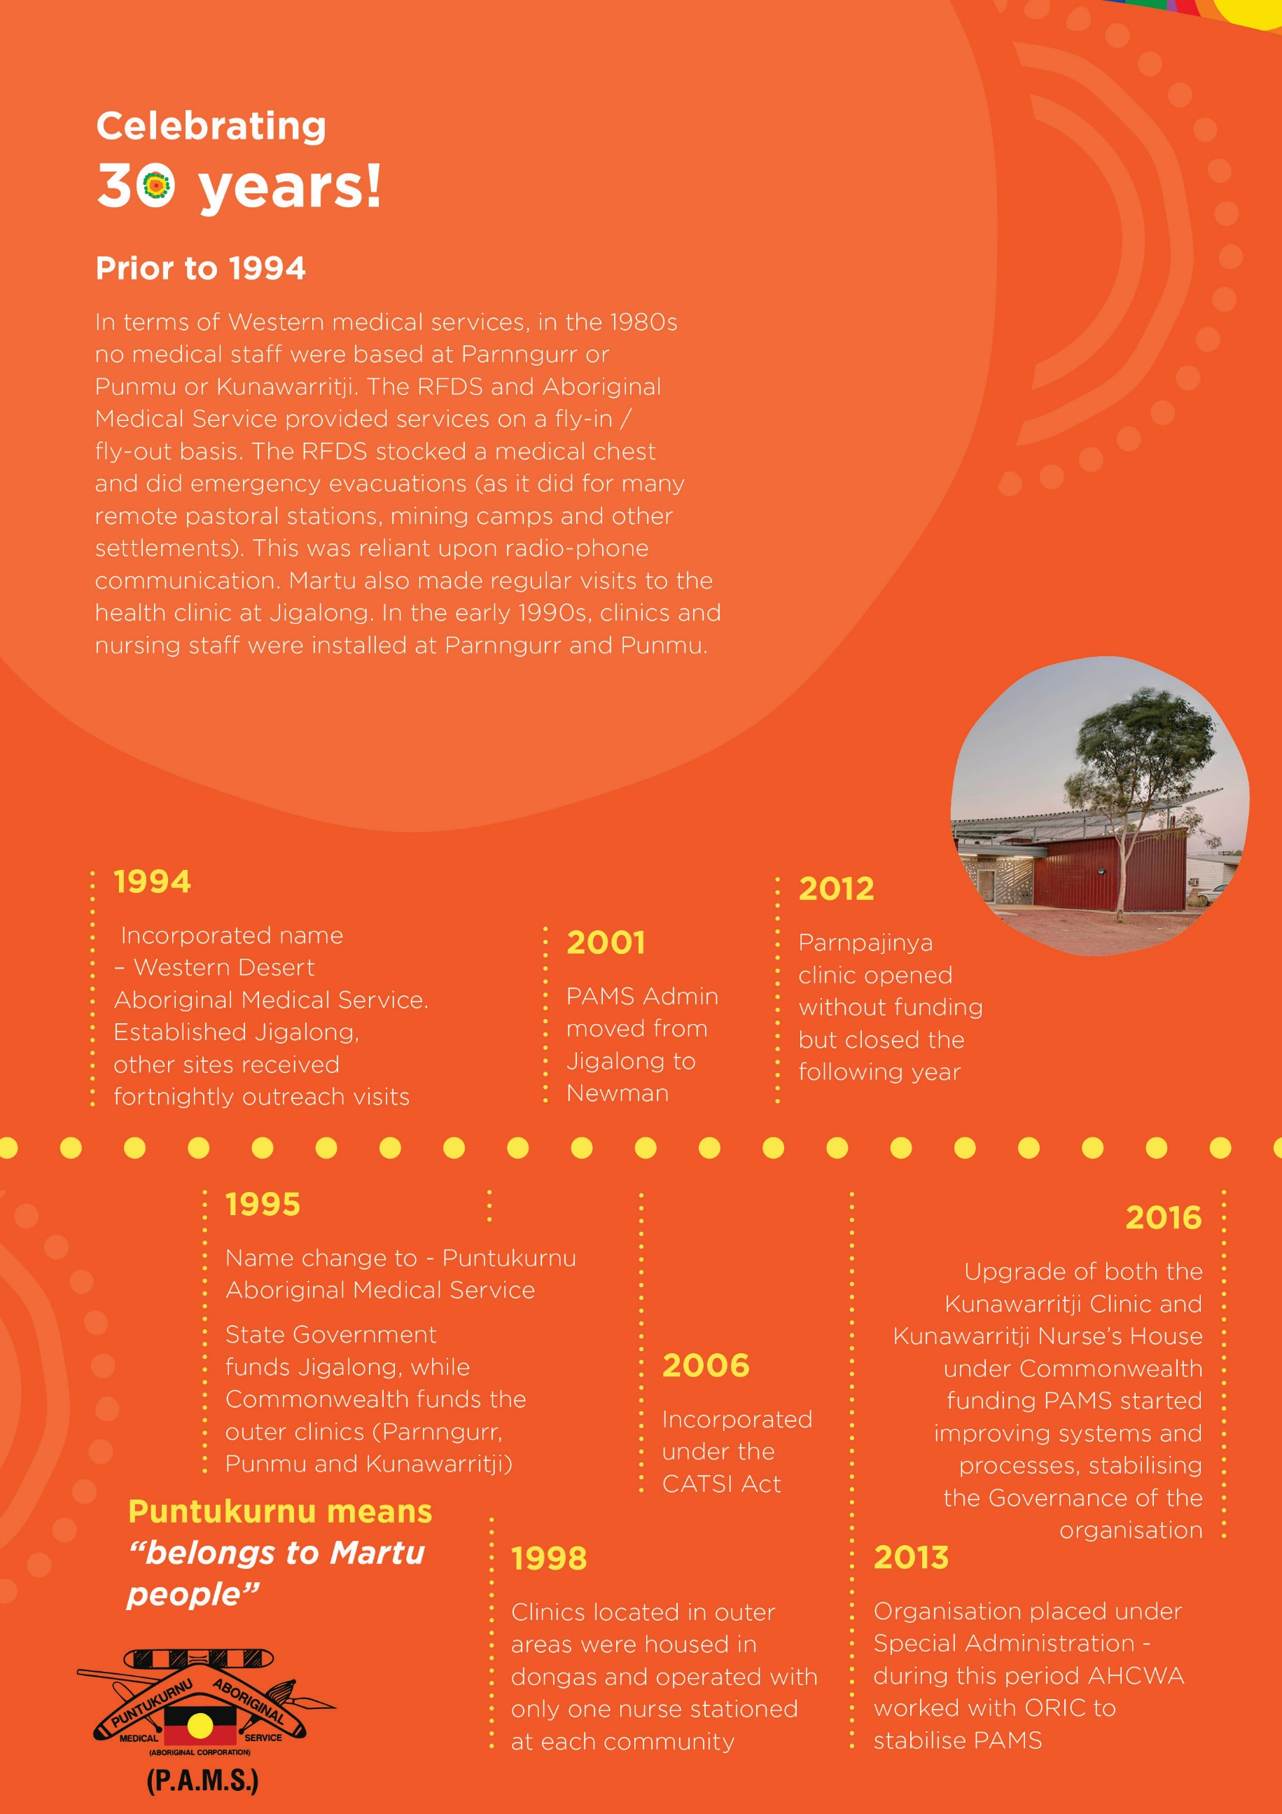

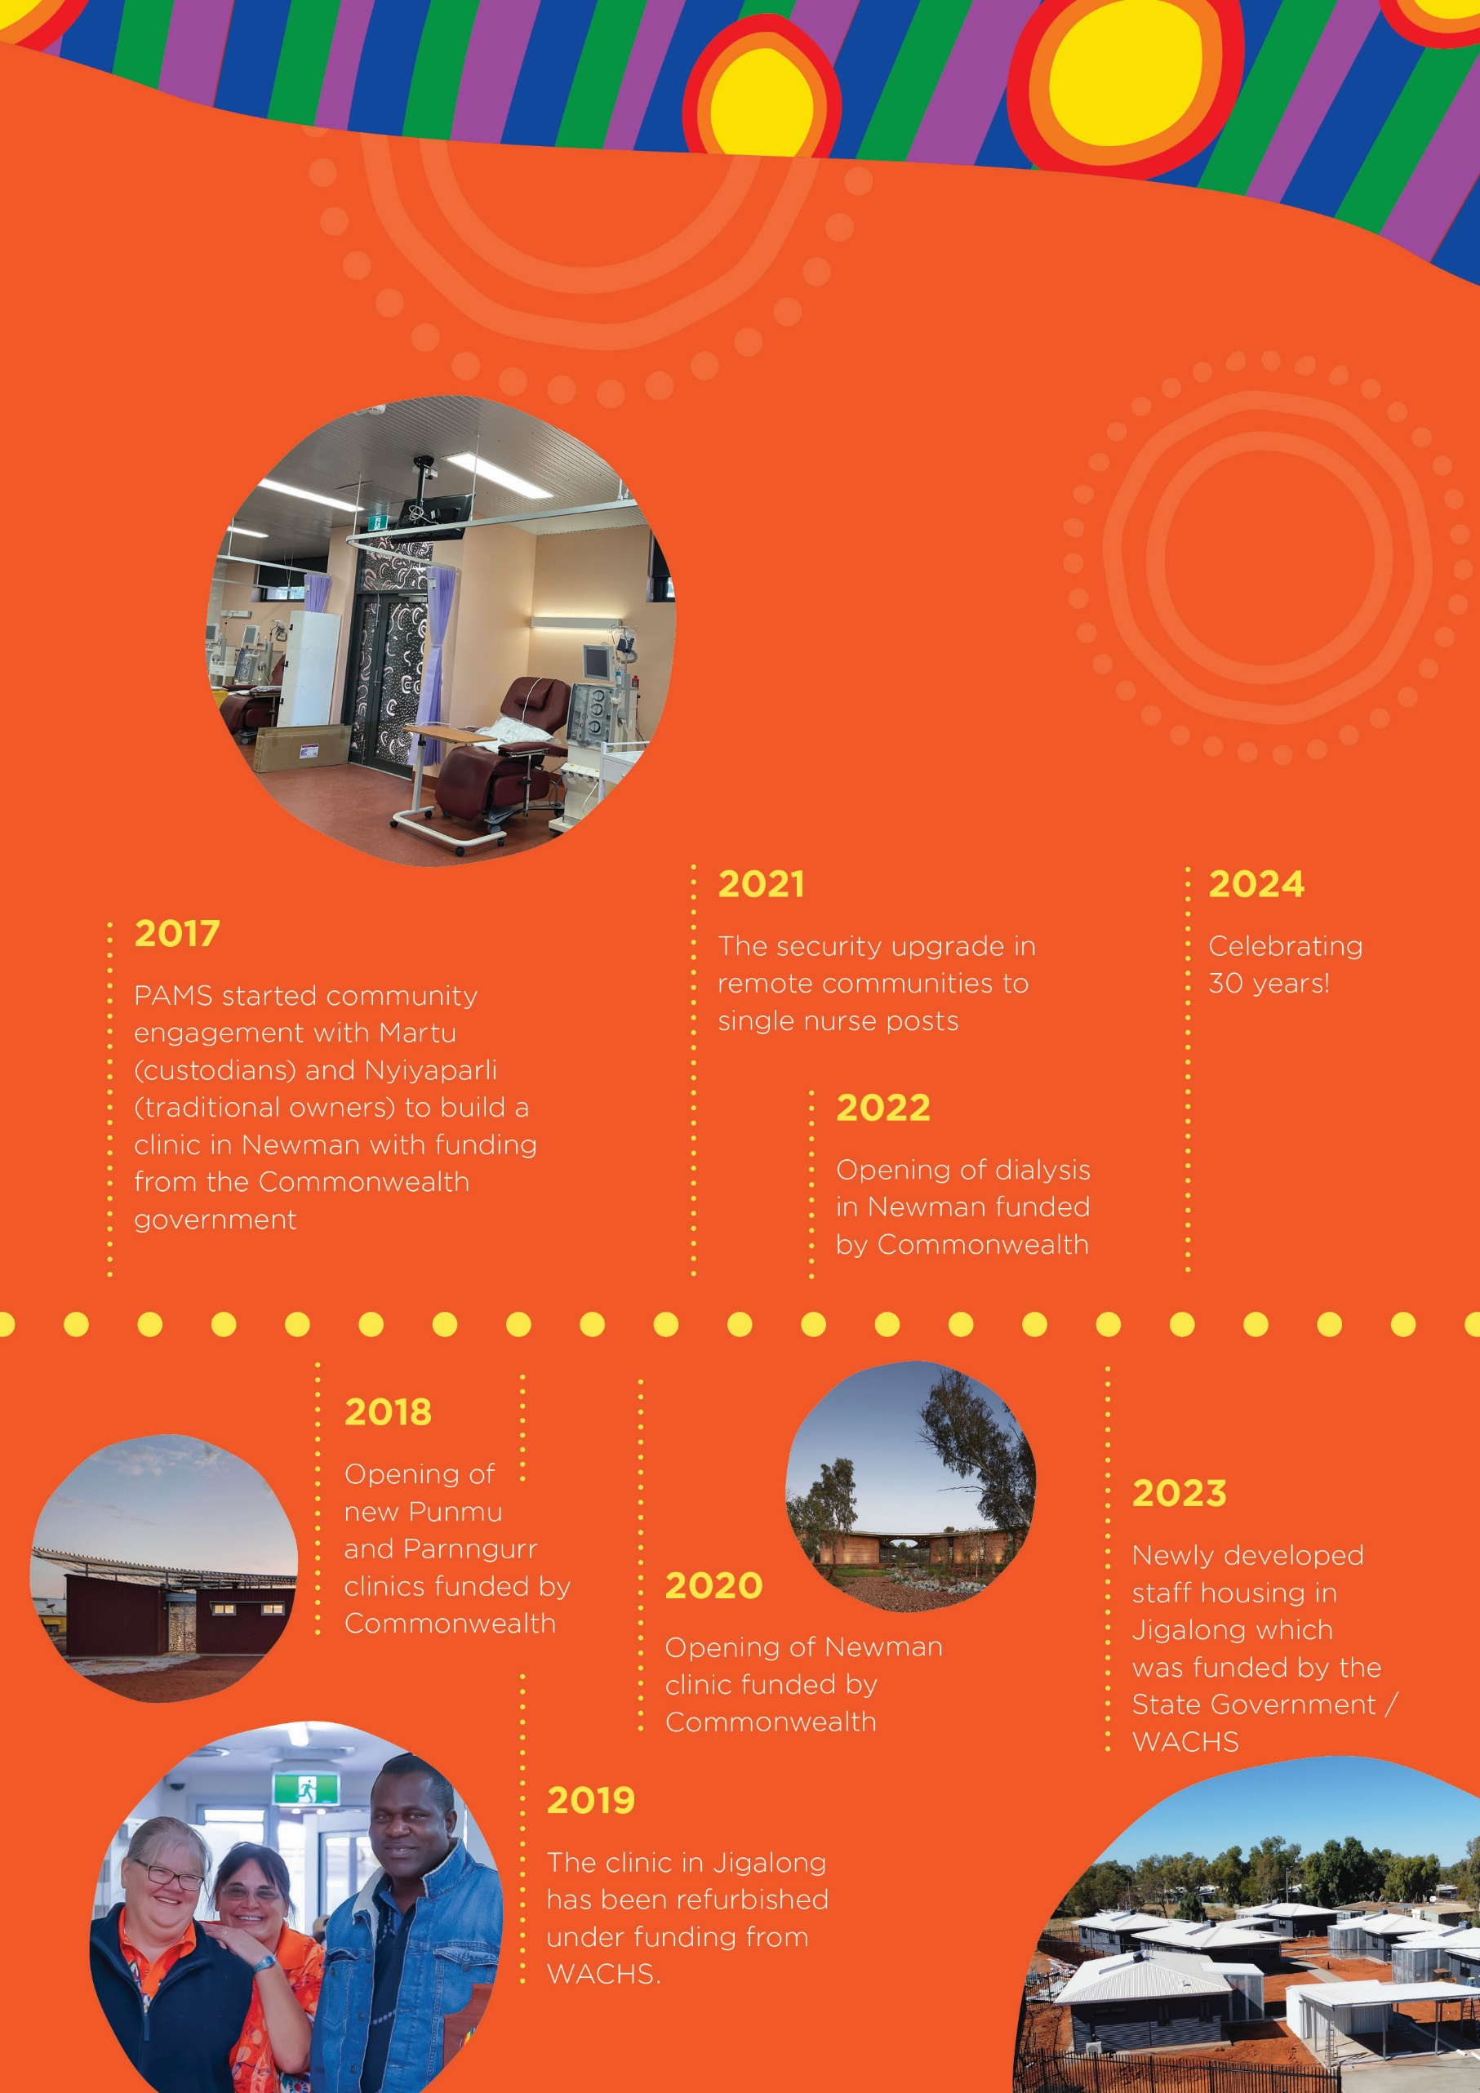

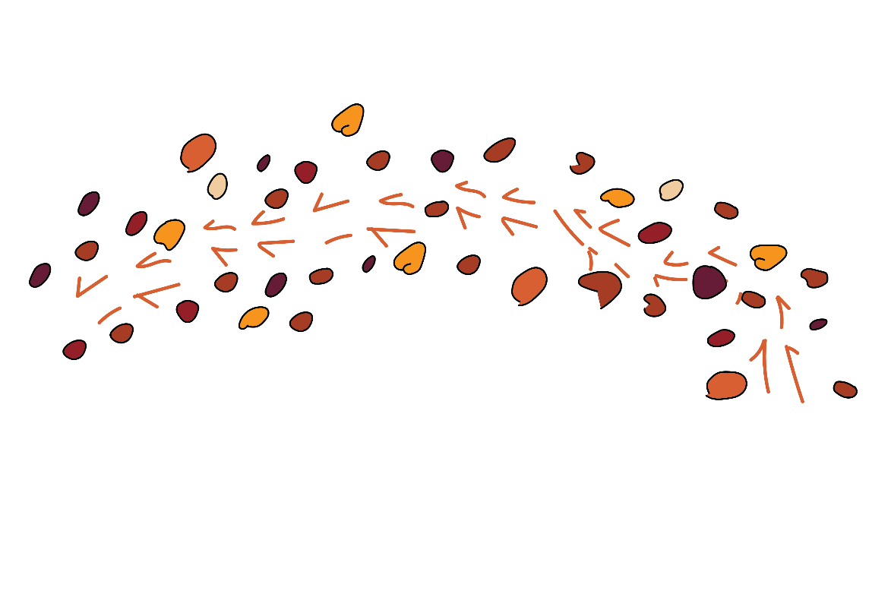

Executive Management Team Contact Details
 | ROBBY CHIBAWE  CEO  pams.ceo@puntukurnu.com
 | Jenny Sala  Director of Corporate Services  pams.dcs@puntukurnu.com  0412 177 271
 | Aimable Ndayizeye  Director of Community and Family Health  pams.dch@puntukurnu.com  0475 714 367
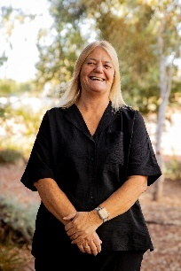 | Christina Hunn  Director of Clinical Services  pams.dcss@puntukurnu.com  0448 008 849



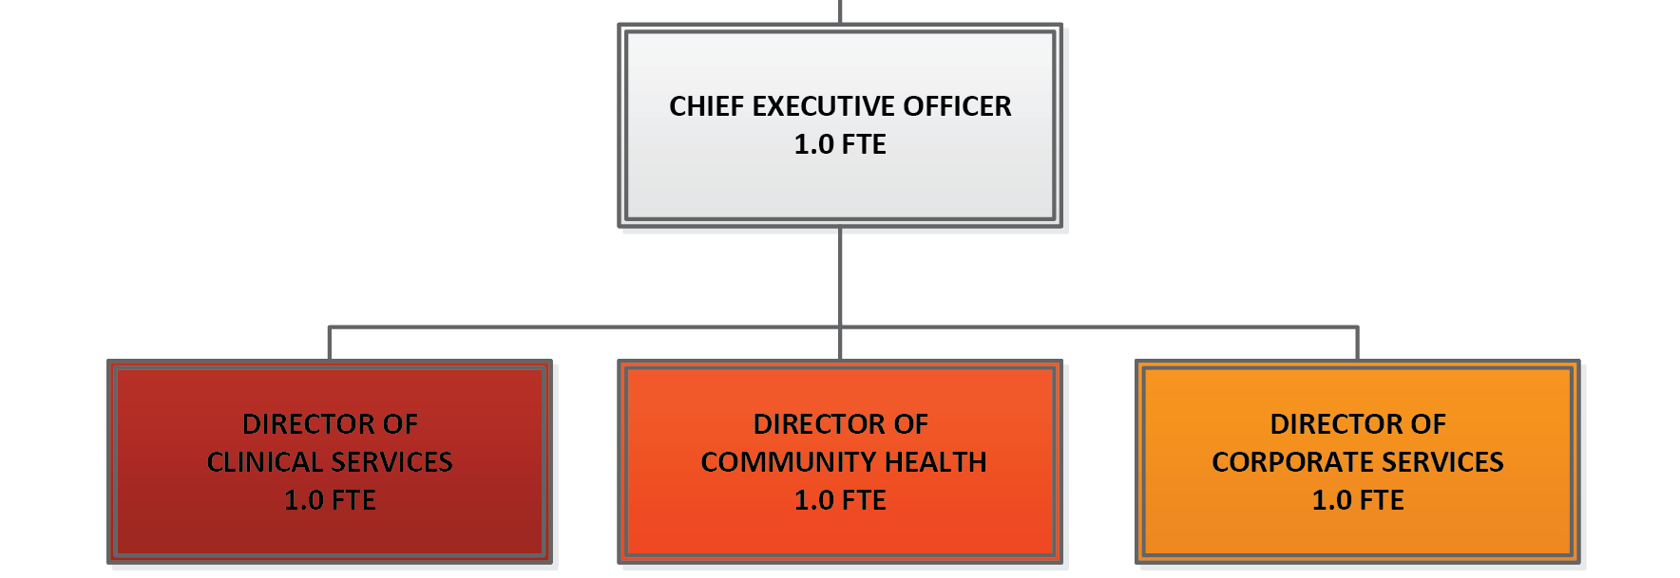
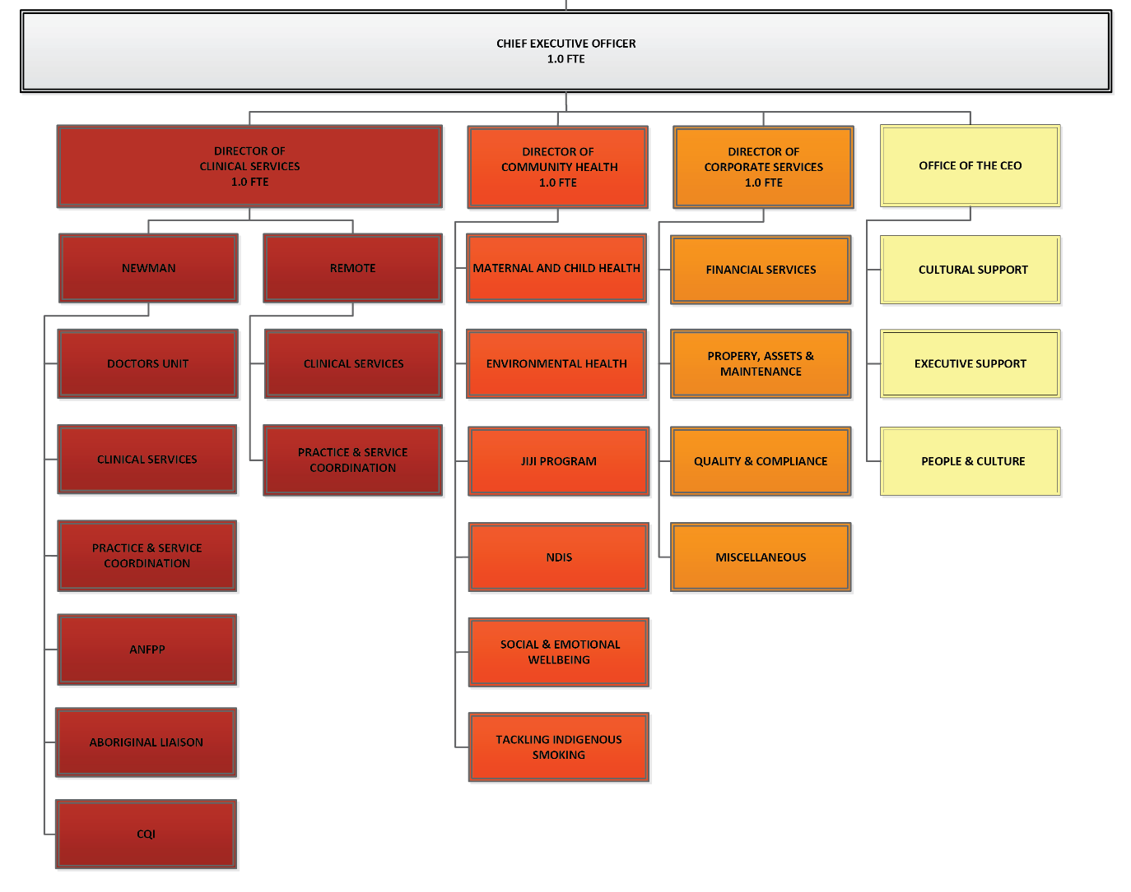
Executive Management Team
De-Identified
Board Endorsed 19/06/25
Punkuturnu Aboriginal Medical Service Board of Directors
Organisational Summary
De-Identified
Board Endorsed 19/06/25
Punkuturnu Aboriginal Medical Service Board of Directors
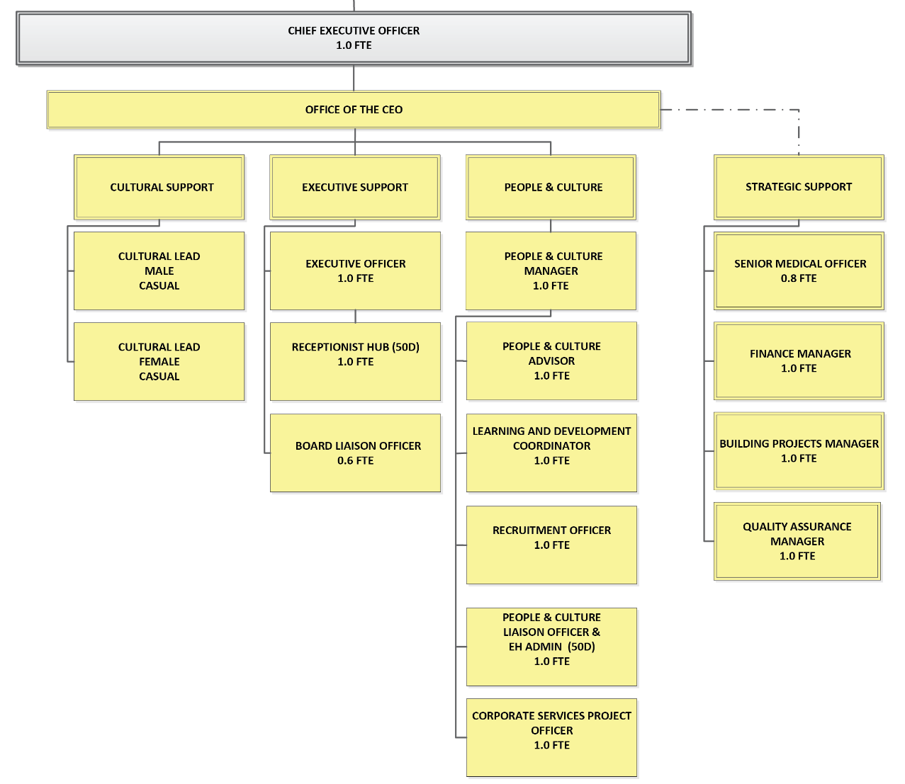
Office of the CEO Structure
De-Identified
Board Endorsed 19/06/25
Dash report line does not report to CEO
Punkuturnu Aboriginal Medical Service Board of Directors

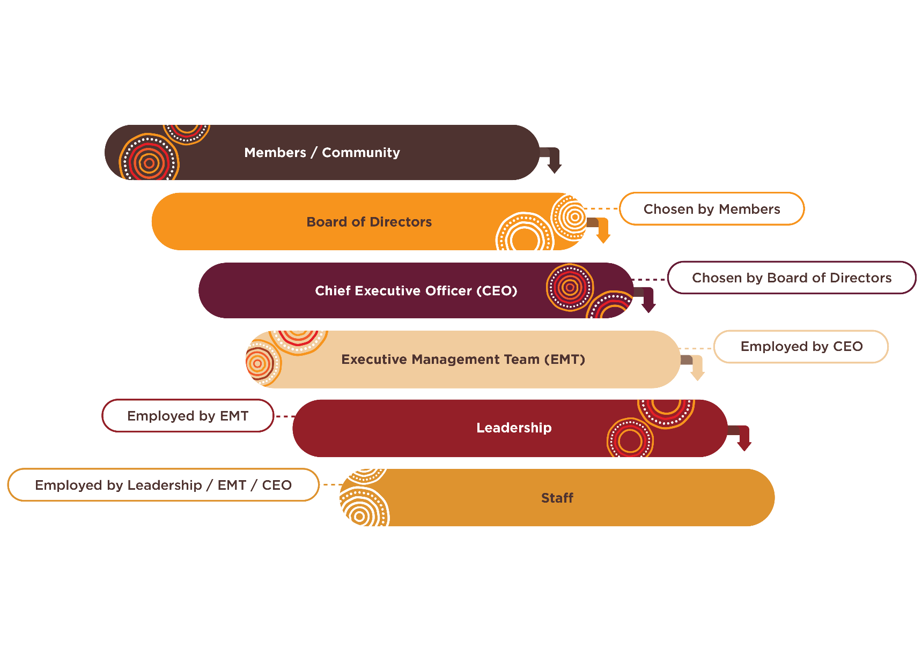
Members Organisational Chart

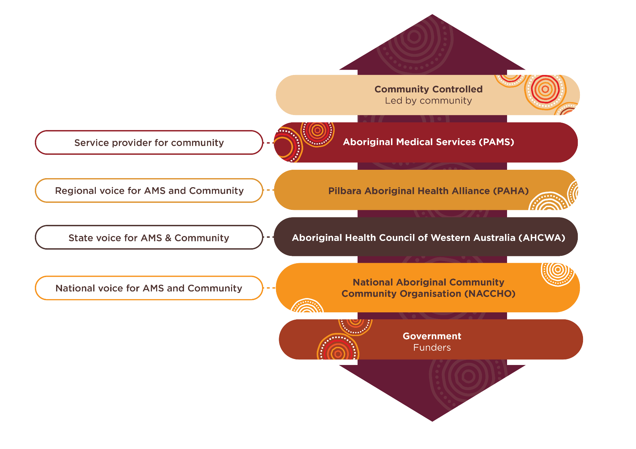
ACCHO Organisational Chart

History of Puntukurnu (Martu - for the people) Aboriginal Medical Service
Puntukurnu Aboriginal Medical Service (PAMS) was officially established in 1994 as the Western Desert Aboriginal Medical Service, delivering primary health care from Jigalong with outreach to surrounding communities. In 1995, the name changed to reflect Martu ownership and purpose — Puntukurnu, meaning “for the people.”
Throughout the 1990s and 2000s, PAMS transitioned from mobile services to permanent clinics in Parnngurr, Punmu, Kunawarritji, and later, Newman. In 2001, administration moved from Jigalong to Newman, and the organisation was incorporated under the CATSI Act in 2006.
After a challenging period of special administration in 2013–2014, PAMS stabilised and began a period of strong growth:
- 2018–2020: New clinics opened in Punmu, Parnngurr, and Newman
- 2022: Dialysis services launched in Newman
- 2023: Staff housing upgrades in Jigalong
- 2024: Celebrating 30 years of service
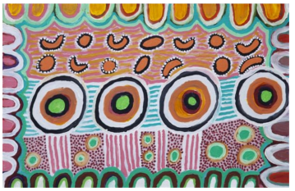
Today, PAMS delivers health care across five communities with a focus on cultural safety, community governance, and holistic care. Its growth reflects the strength, resilience, and leadership of Martu people.

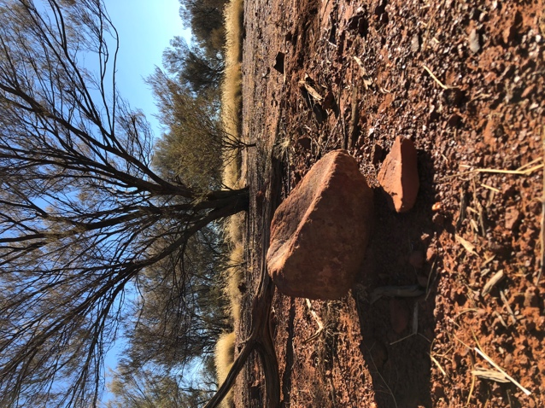
Meet the Martu (Mardu) People History
Photograph: 1 a grinding stone from old camp
sites of the Pujimen (bushmen)

The Martu are the traditional owners of the country which extends from the Great Sandy Desert in the north to around Wiluna in the south. Across this country, Martu share a common law, culture and language and are one of the oldest living cultures in the world with archaeological evidence dating artefacts as old as 39 000 years.
At its peak, there were over 600 different kin/language groups in the Martu region.
Like many Aboriginal and Torres Strait Islander people, Martu speak or understand numerous languages. For most Martu, even the children, English is a second, third or other language.
The Martu were some of the last of Australia’s Indigenous people to make contact with European Australians with many migrating from their desert lands into neighbouring pastoral stations and missions in the 1950s and 1960s. Sometimes this migration followed the Canning Stock Route north to the eastern Kimberley or south to Wiluna and then east to Warakuna and Warburton. Many older people have first-hand experience of life prior to European contact and have extensive traditional cultural and ecological knowledge of their country. In 2002 the Martu were awarded native title rights to over 13.6 million hectares of the Western Desert. This is referred to as the Martu Native Title Determination. The determination stretches from the Percival Lakes in the north to south of Lake Disappointment, and from near Jigalong and Balfour Downs in the west to the Kiwirrkurra and Ngaanyatjarra native title determinations in the east.
The main communities in the determination are Jigalong, Parnngurr, Punmu and Kunawarritji. Jigalong is the most well-known of the communities having been established as a maintenance depot for the rabbit proof fence. It was made famous as the subject of a movie about three children who walked back from Moore River Settlement north of Perth called Rabbit Proof Fence (2002). Jigalong was subsequently turned into a mission before being handed over to the Martu people in 1969.
The other communities were established in the mid-1980s as a part of the then homelands movement, when people decided to return to live on their country.
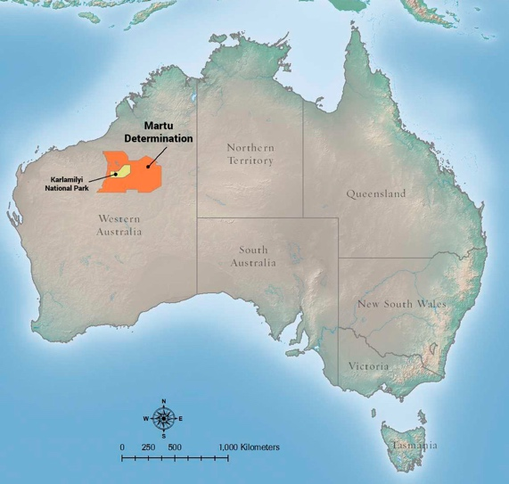
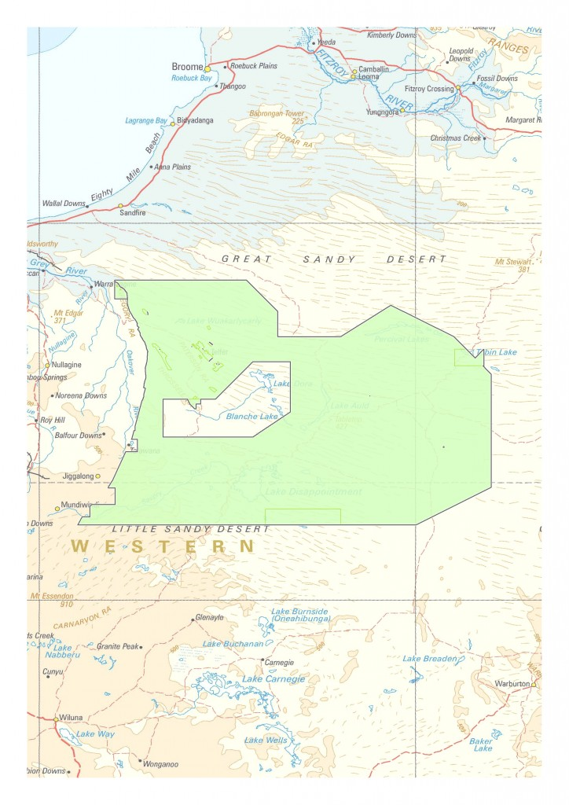
As with many remote communities nationally, population numbers in the communities vary during the year.
Image: 2 Martu Native Title Determination (Kanyirninpa Jukurrpa)
Image: 2 Martu Determination (Central Desert Native Title Services, 2019

“For Martu people who live in this land, it’s the song line and the land around this area, it’s so special to them. We connect with the land – it’s our dreaming, our spirits, our culture.
It’s my life. It’s all Martu people’s ancestors, our great grandmother’s and grandfather’s. What the old people told me – to try and look after our culture, law and the land.
So we need to protect Martu culture and the land and the community that lives around it.”
Image: 3 Rabbit Proof Fence 2002, (DVD), Hanway Films
— Clifton Girgirba, Martu Ranger, KANYIRNINPA JUKURRPA

Meet the Nyiyaparli (Nee-Ya-Par-Li) People
The Nyiyaparli people are the Traditional Owners of approximately 36,684 square kilometres of land and waters in the East Pilbara region, including the township of Newman in Western Australia.
It took almost two decades for the Nyiyaparli people to achieve Native Title recognition. Their first claim (WAD 6280 of 1998) was lodged with the National Native Title Tribunal on 29 September 1998. The Federal Court’s determination brought together representatives from the court, state and federal governments, and Traditional Owners to witness this historic milestone.
The Determination Area spans around 40,000 square kilometres of traditional Nyiyaparli Country. It includes the town of Newman, the Aboriginal communities of Jigalong and Parnpajinya, several pastoral leases, and key mining operations.
While all parts of Country are important to the Nyiyaparli people, areas of particular cultural and environmental significance include the Fortescue Marsh, Weeli Wolli Creek, Coondiner Creek, Caramulla Creek, and Savoury Creek. Major geographic features such as the Hamersley, Chichester and Ophthalmia Ranges, as well as the Fortescue and Oakover Rivers, are also prominent across the landscape.
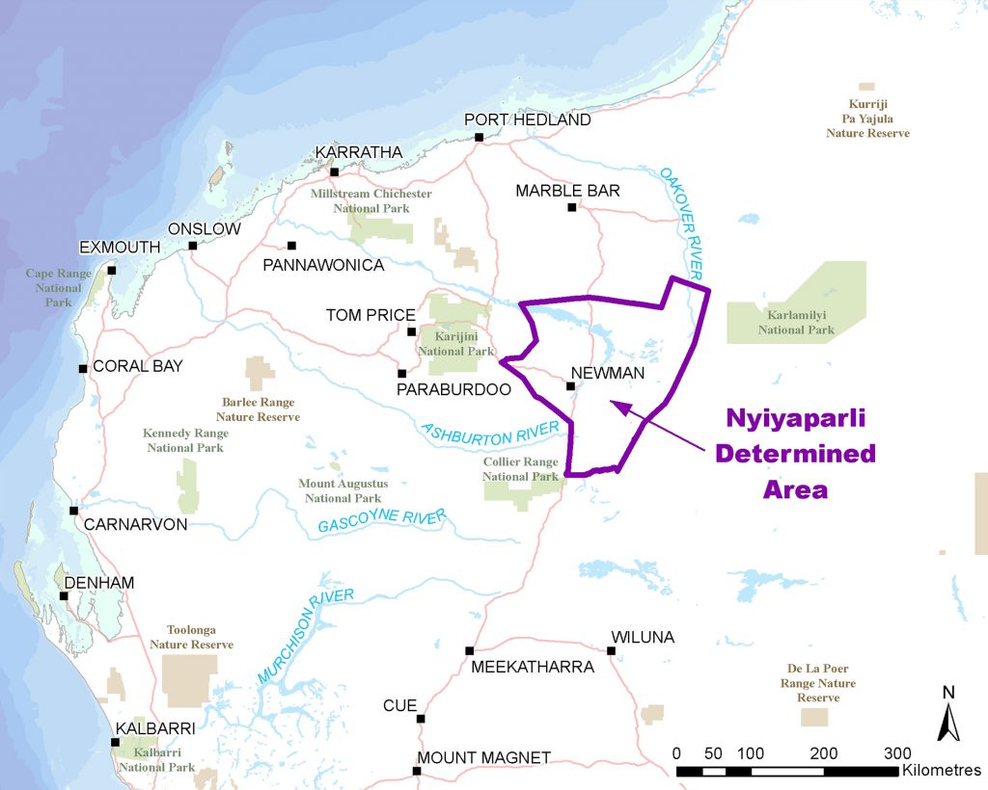
The Determination Area contains many places of deep cultural significance, including ceremonial sites, songlines, permanent pools, and natural resource areas that are vital to the continuation of Nyiyaparli culture and connection to Country.

Community Background
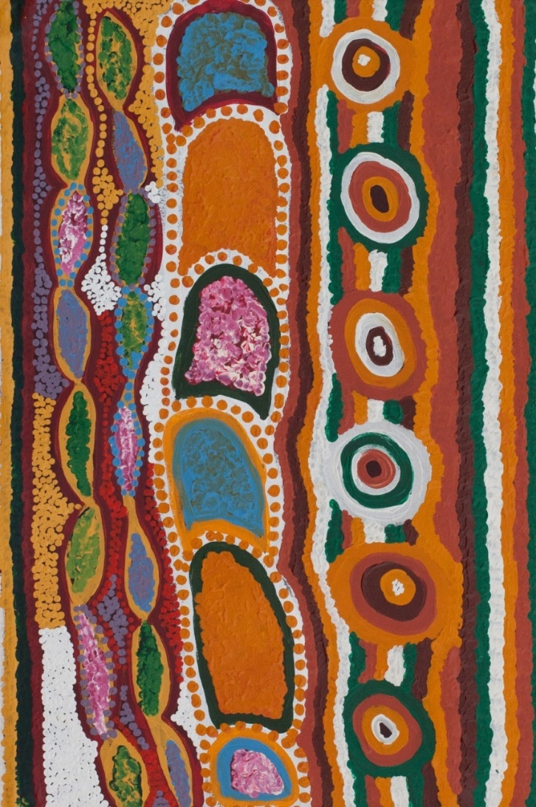
You are a guest in this ‘country’ delivering PAMS services and undertaking PAMS commitment to improved health care and health outcomes for the Martu and Nyiyaparli People.
Working across cultures requires patience, understanding and commitment of both groups.
Cultural issues influence both your private and working life on a daily basis and respectful sincerity in observing the protocols of the Martu and Nyiyaparli people will determine your working experience.
Acknowledgement of elders past and present and emerging and traditional owners of the area is considered respectful to the community and is an important recognition of their role in society.
Traditional medicine may be used in conjunction with clinic health practices. Marban is the title given to traditional cultural healers and often the Martu may be seen by a Marban prior to coming to the clinic and in some instances after.
Participating in sporting activities is extremely popular with young adults. In most Communities football, basketball and softball are the main sporting pastimes. These events often involve competing with other teams either in their own community or having to travel (often hundreds of kilometres) to another community.
At weekends a favourite for many Martu is hunting, which remains an important element in Martu culture and lives. All four remote communities (Jigalong, Parnngurr, Punmu and Kunawarritji) have a strict ‘no alcohol’ policy. This must be adhered to by all members of the community and visitors.
All PAMS staff must therefore adhere to this policy.

Cultural Sensitivity

Avoidance Relationships
In Indigenous culture, there are specific cultural protocols that influence interpersonal interactions, including strict rules about who can engage with whom. These protocols are guided by skin group relationships and can result in avoidance relationships, where certain individuals are required to avoid direct contact or communication with one another.
These cultural obligations may impact how people move through or engage with public spaces, including workplaces and clinics. It's important to be understanding and respectful of these practices, as they play a significant role in maintaining cultural integrity and respect within the community.

Sorry Time and Lore (cultural traditions)
The news of a Martu / Nyiyaparli person passing away is extremely sensitive, particularly when the death is unexpected or the result of an injury or accident.
It is very important that the information is conveyed to the right members of the family by the right person in the right way.
If an Aboriginal Health Worker or Liaison Officer is available you should approach them and enquire as to who is the right person to pass the news on to the family, alternatively you could approach a PAMS Community Board of Director, an Elder or call PAMS Management staff. If you are the person informing the family of the death try not to use the person’s name, you instead use phrases like ‘the brother of …..’.
The period of time following the death of a community member and up until after the funeral may be referred to as Sorry Time. During this time meeting, events and activities may be cancelled due to Sorry Business happening in the community.
For many months to years after a Martu has passed away their name is not spoken so a different name might be used in reference to the deceased. People with the same name as the deceased will be known as “Nyaparu” or may be known by their initials or take on another name.

Cultural Traditions
It is important to note that cultural business is sacred and is treated with respect at all times.
Lore is typically held between November and April, during which a range of Men’s and Women’s Business is conducted. It is important to respect cultural protocols — Men are not permitted in Women’s Business areas, and Women are not permitted in Men’s Business areas.
During Lore, men undergoing initiation must not be seen in public and will not attend the clinic. In some cases, they may permit a Remote Area Nurse (RAN) to visit their site for treatment, usually in the evenings. Where possible, this should be a male clinician in accordance with cultural preferences.
Local cultural intelligence and guidance should always be considered before planning any travel to communities during this period.
See specific location details below (under each community), regarding lore grounds and no go areas

Martu History and Culture Resources
- https://www.kj.org.au
- http://www.wdlac.com.au/martu/
- https://www.centraldesert.org.au/native-title-item/martulinks/
- http://www.wangkamaya.org.au/pilbara-languages/martu-wangka-overview
- https://www.camecoaustralia.com/community/stories/who-are-the-martu
- https://www.karlka.com.au/

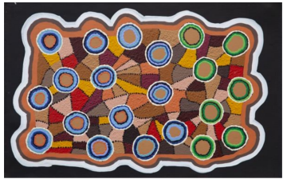

Arriving in Newman and Working with PAMS
When a team member joins PAMS, the Corporate Services team assists with travel logistics and if applicable relocation arrangements.

Arriving in Newman:
If travelling by air, a designated team member will be organised to meet you at the Newman Airport on the day of your arrival; This person will be holding a PAMS sign for you to easily identify them.
On arrival into Newman, the team member will provide a brief tour of Newman and town amenities including the shopping precinct, fuel stations and other places of interest. You will then be directed to your accommodation which may be PAMS transit housing or accommodation via an external provider, this is dependent on availability.

Transit Accommodation (by PAMS)
PAMS has dedicated accommodation for transiting employees and visitors which may have shared kitchen, utilities and seating areas.
Each room has a welcome to Newman booklet, which will provide you with all the necessary information for you to navigate around Newman.

First couple of days in Newman
Your first few days in Newman and at PAMS will be spent meeting with the management, and attending welcome to country and a comprehensive induction. You may be scheduled for additional mandatory training where applicable. This is followed by Site based/Departmental orientation (led by respective managers) and may take up to over 2 – 4 weeks.

Mail Plane (Remote Community Travel)
Whilst travel to Jigalong is mostly undertaken via road, you will be travelling on the mail plane when travelling to remote communities of Parnngurr, Punmu and Kunawarritji. All mail planes to remote communities are scheduled for 9.00 am departure every Thursday. The limit on luggage is 15 kg and any weights above this amount are required to be paid by the traveller.
Alternatively, you have the opportunity to send through additional luggage by road with our team members who visit community regularly for different projects.

Considerations before Travelling to Communities
Groceries - As fresh food availability can be limited in remote communities, we recommend that you do a shop in Newman prior to your departure, this can be completed in person or via a Click and Collect (if your transit period is short). It is appropriate to arrange this a day prior to avoid last minute changes. If travelling by air, the food can be added on top of the 15kg limit, and costs relating to this additional ‘luggage’ will absorbed by PAMS ; Your shopping will be weighed by the Corporate Services team at the Administration Hub on a Wednesday afternoon.
Phone and Internet Facilities – Whilst Punmu and Kunawarritji have no mobile service; Telstra is functional in Jigalong and Optus in Parnngurr. All communities have landline phones and internet facilities. Downloading capacity in remote communities is limited; everyone is encouraged to download personal entertainment items prior to departure to communities.
Board and Lodging – All employees and approved visitors are provided with Board and Lodging when in communities.
Travel – Due to safety reasons, PAMS does not recommend employees travelling to
communities in their personal vehicles. We discourage traveling with pets for the same reason.
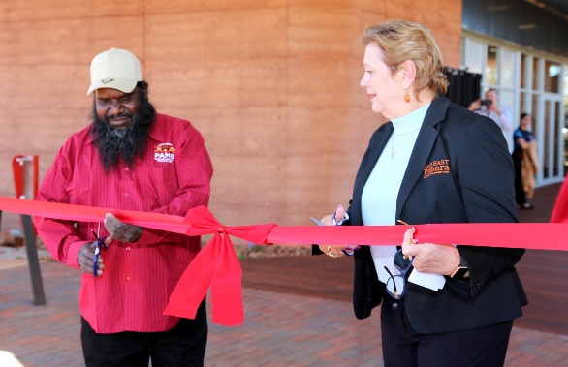
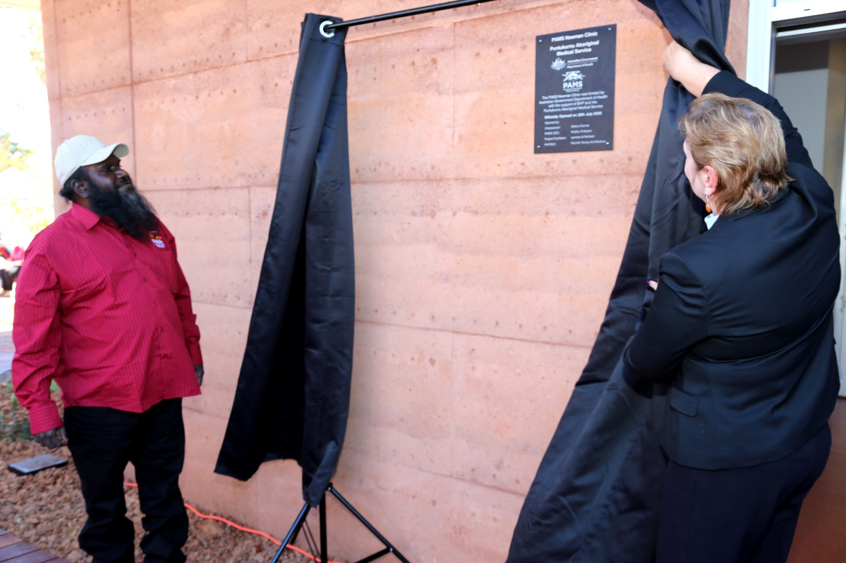
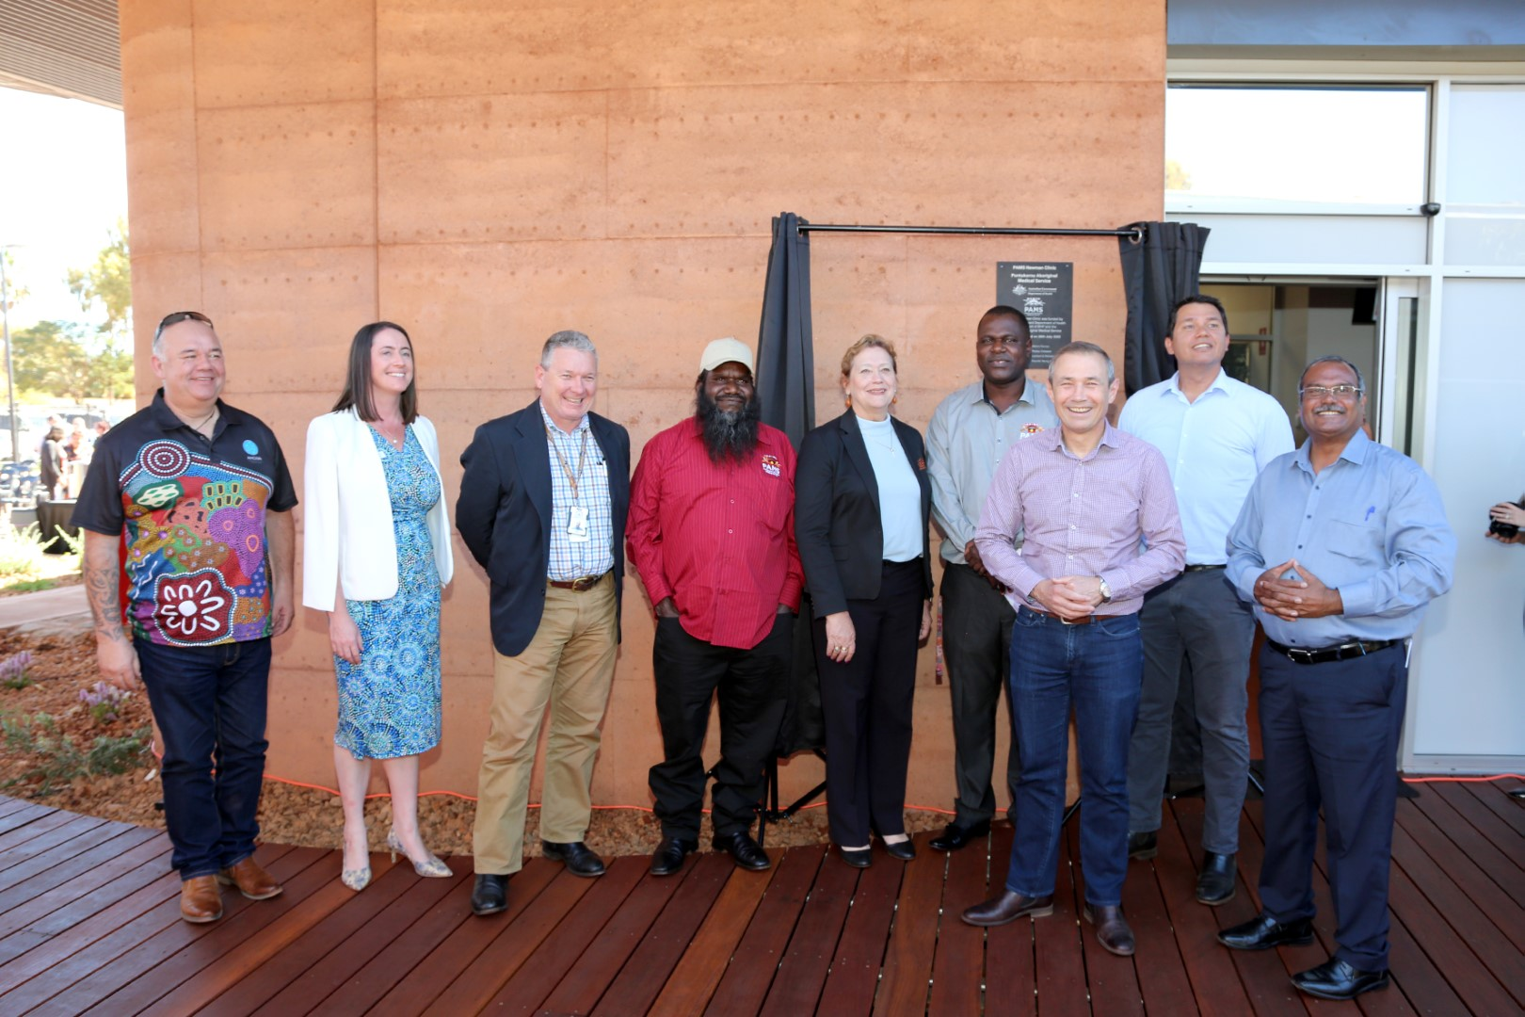

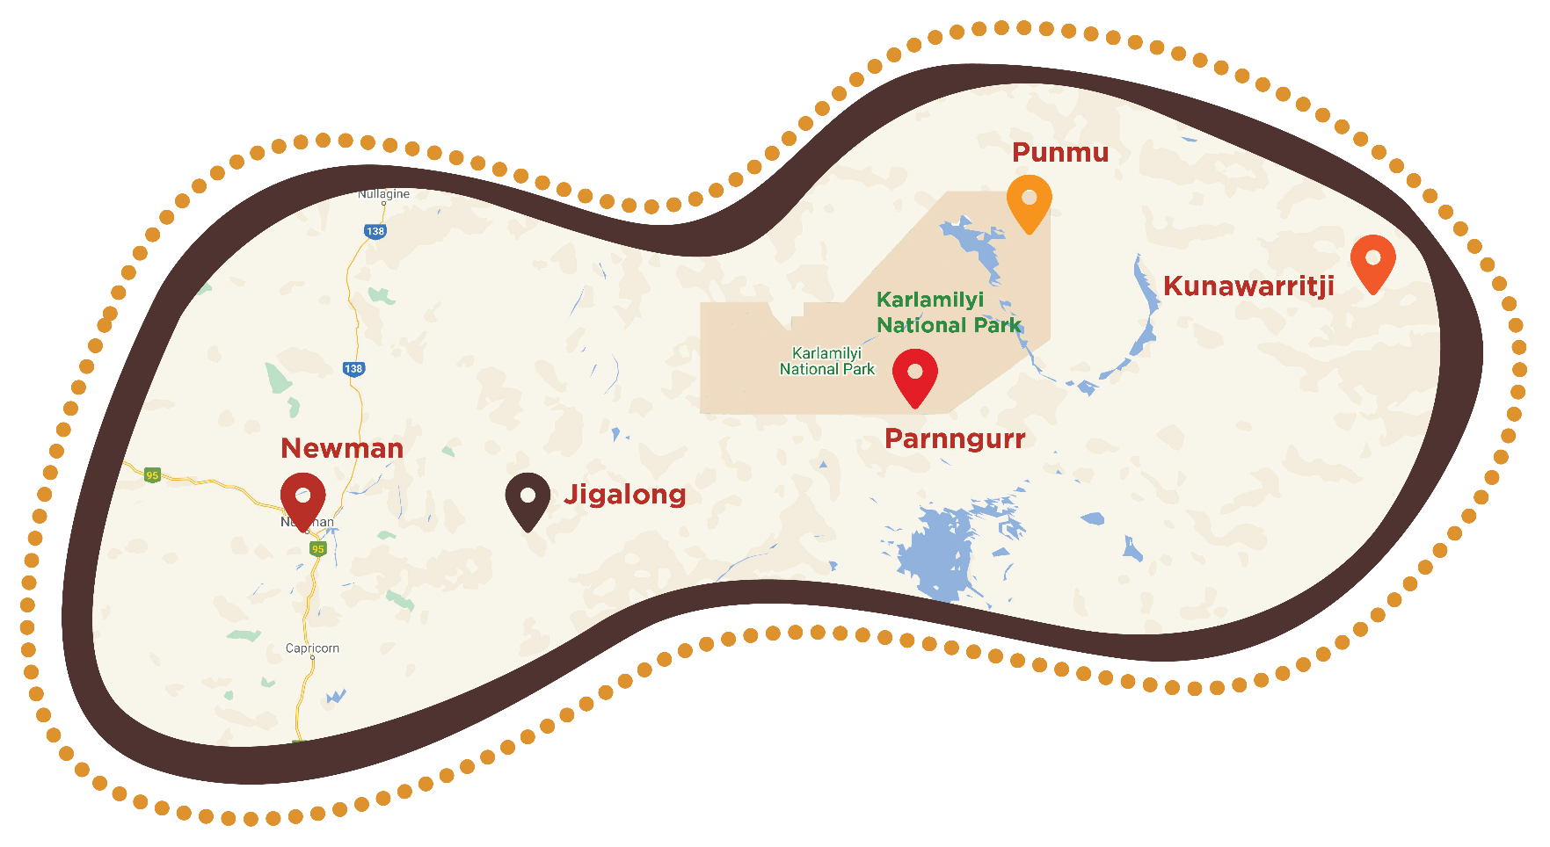
Our Clinic Locations and Distances

ORIGIN | DESTINATION | DISTANCE IN KMS | DRIVING TIME IN HRS
Newman | Jigalong | 165 | 2
Newman | Cotton Creek | 350 | 4.5
Newman | Punmu | 790 | 7
Newman | Kunawarritji | 970 | 9

PAMS Newman Clinic
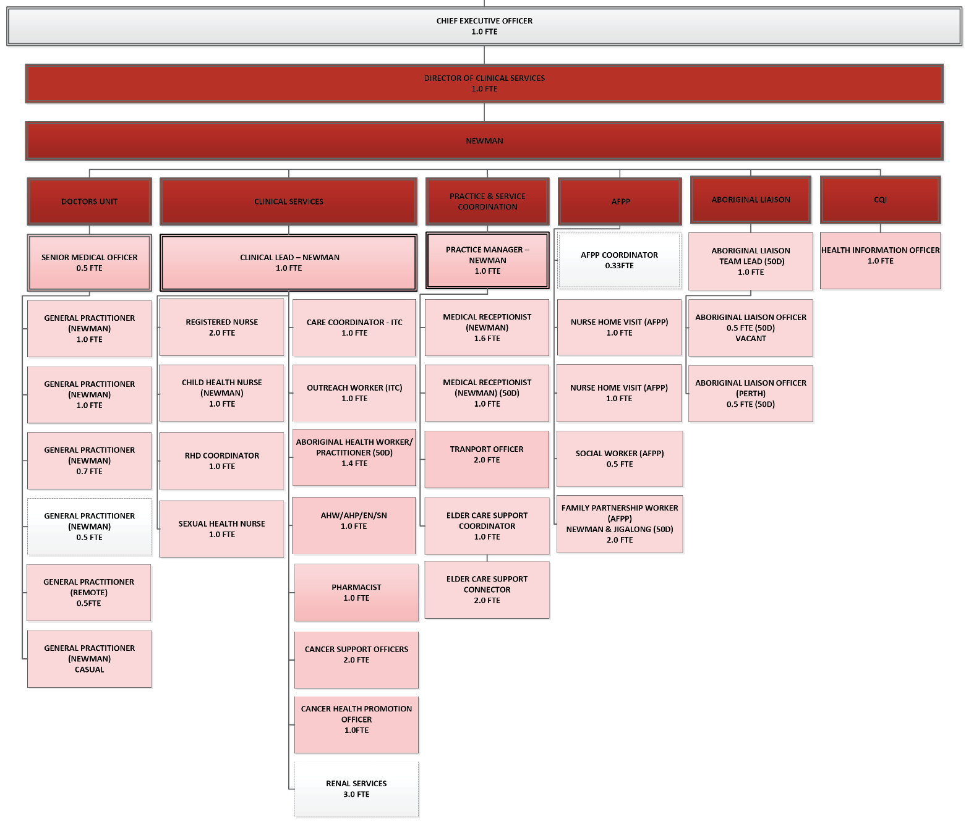
PAMS Newman Clinic is a newly built clinic, which finished completion in May 2020, with services beginning from August 2020.
Punkuturnu Aboriginal Medical Service Board of Directors
Community Services Newman
De-Identified
Board Endorsed 19/06/25
White Positions – External Consultants/Contractor

Opening Hours:
9:00 to 13:00 and 14:00 to 17:00 Monday, Wednesday, Thursday and Friday
(Closed from 13:00 to 14:00)
9:00 to 13:00 Tuesday

Contact Details:
Phone: 08 9111 1777 Fax: 08 9111 1778
Email: newman.clinic@puntukurnu.com

Visiting specialists for PAMS Clinics
PAMS sites hosts a wide range of visiting medical and allied health specialists including:
- Paediatrician
- Renal Physician
- Ear and Hearing Health Services
- Optometry Services
- Podiatry Service
- Dietician
- Physiotherapy Service
- Diabetes Educator
- Mental Health Services
- Women’s Health Obstetrics
- Dental

Dialysis Centre
PAMS’ partnership with Purple House has laid the foundation for nurse-assisted dialysis in Newman. The Dialysis Centre is the first of its kind for Newman and its neighbouring communities, providing accessible healthcare to both Indigenous and non-Indigenous residents in the region.
Funded by BHP, the Centre is equipped with state-of-the-art dialysis machines and is managed by Purple House. The service is delivered by specialist nurses trained in dialysis treatment, with capacity to treat up to 10 patients per day.

Staffing
The Dialysis Centre is currently staffed by:
- Pilbara Regional Dialysis Coordinator
- 2 Dialysis Nurses

Corporate Services
PAMS Corporate Services team is responsible for delivering the essential operational, governance, and administrative functions that support the organisation’s day-to-day and strategic work. The team oversees finance, human resources, assets and maintenance, quality assurance, administration, and executive support.
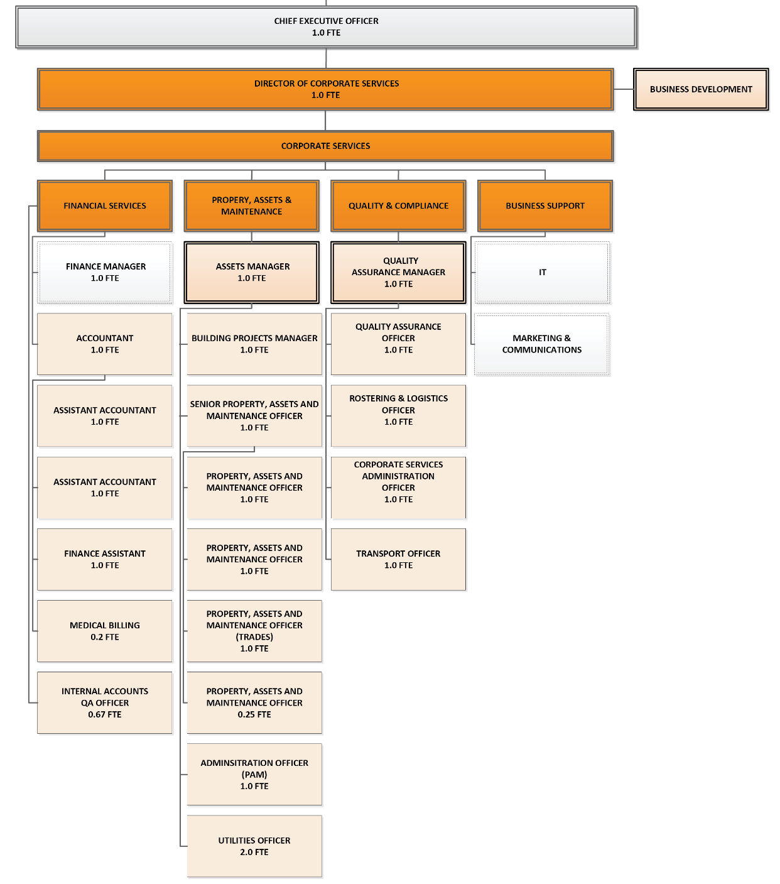
The team operates across several locations in Newman to ensure effective service delivery across all areas of the organisation.
Corporate Services Structure
De-Identified
Board Endorsed 19/06/25
White Positions – External Consultants/Contractor
Punkuturnu Aboriginal Medical Service Board of Directors

Location and Staffing
- Newman Hub (Newman Clinic site) – Office of the CEO
- Arika Place – Assets Team
- Hilditch Avenue – Finance, People & Culture, Quality Assurance Teams

Opening Hours:
Monday to Friday – 8:30 AM to 5:00 PM

Contact Details:
Phone: 08 9177 8307
Fax: 08 9175 0990
Email: pams@puntukurnu.com

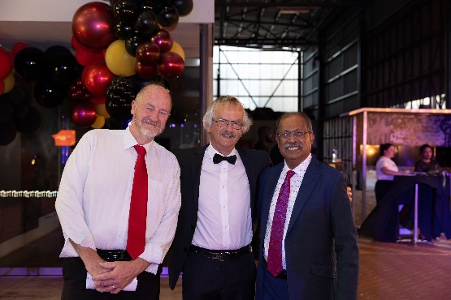
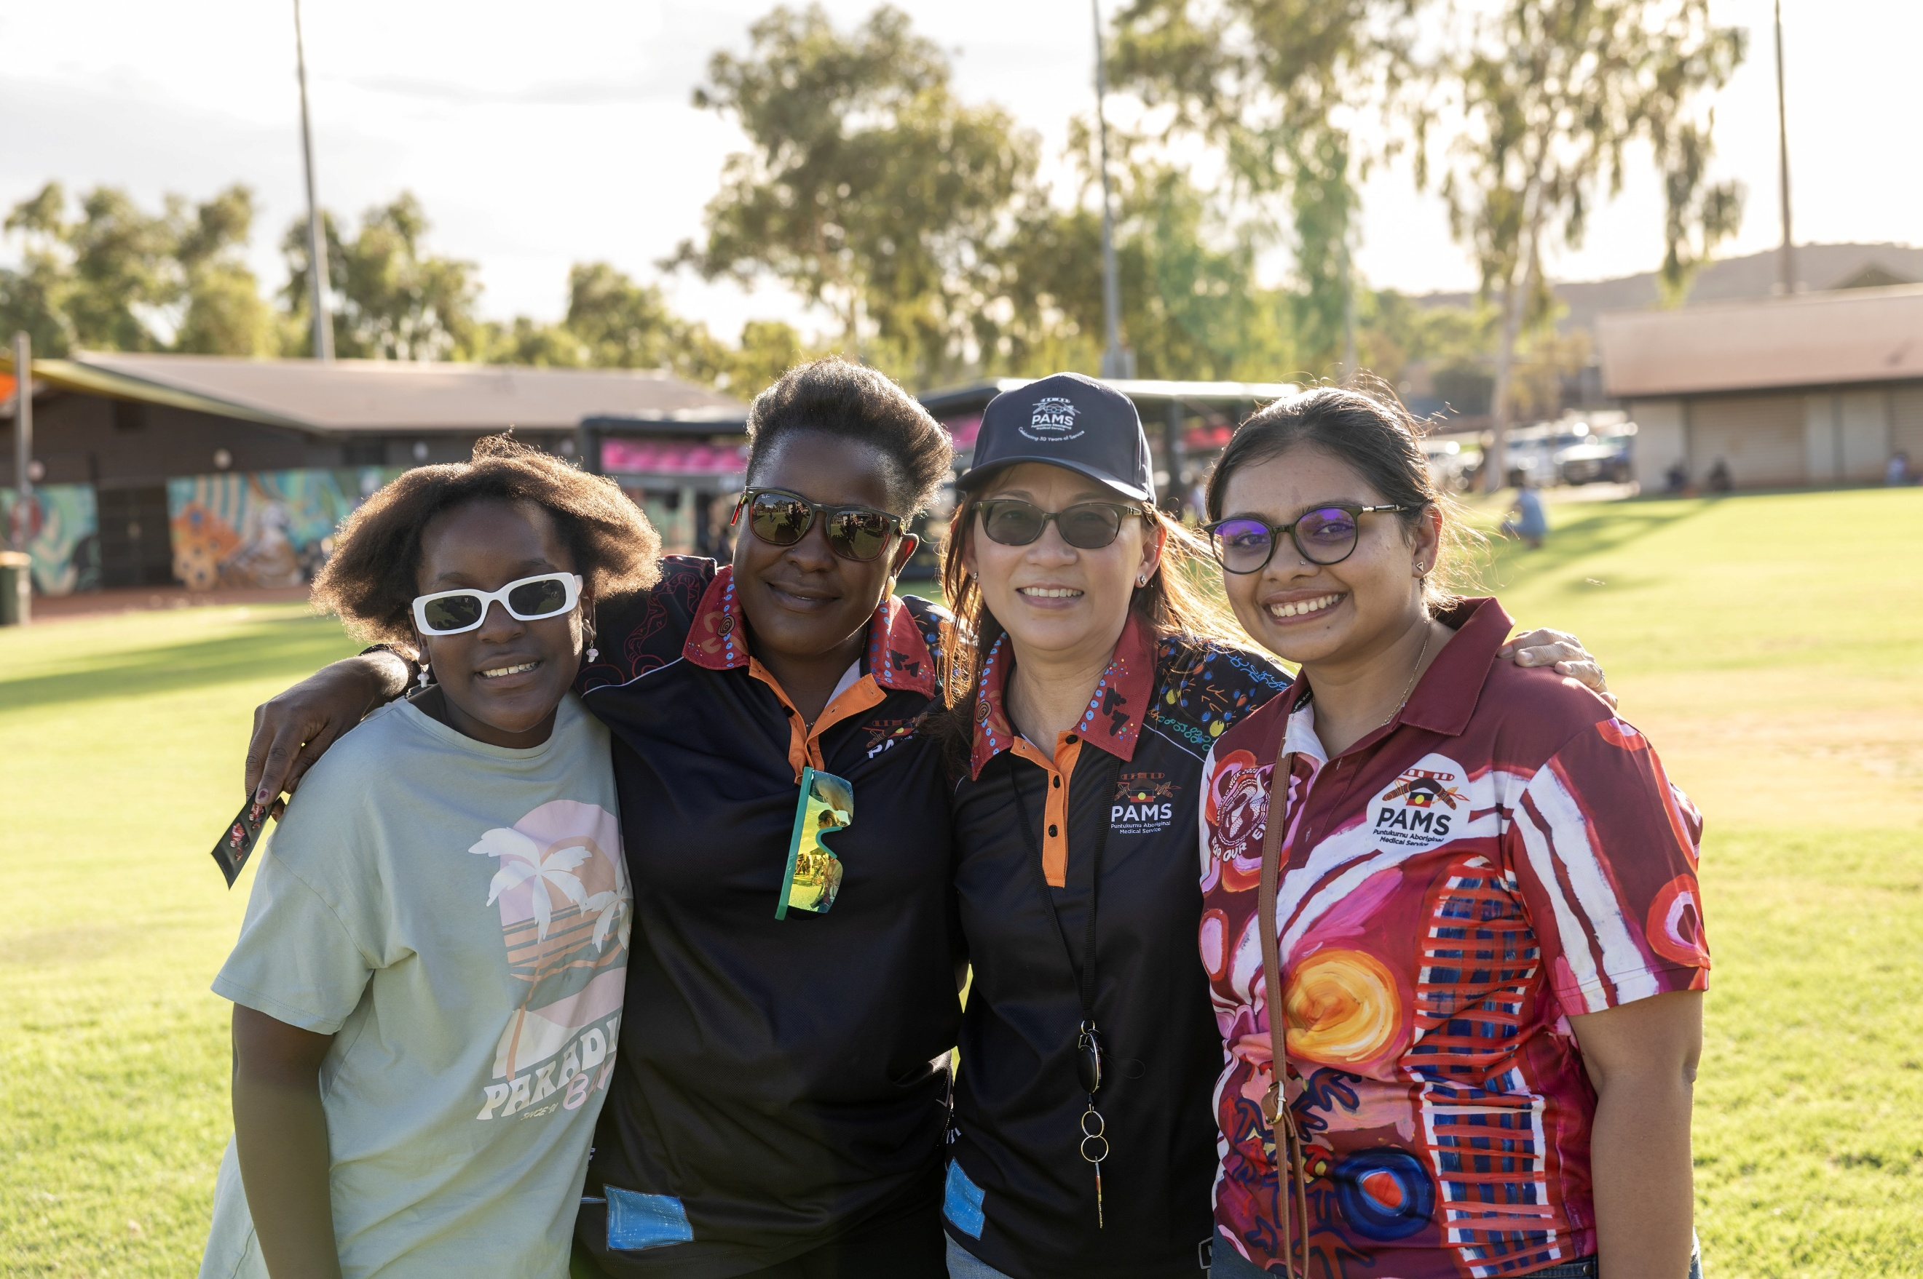
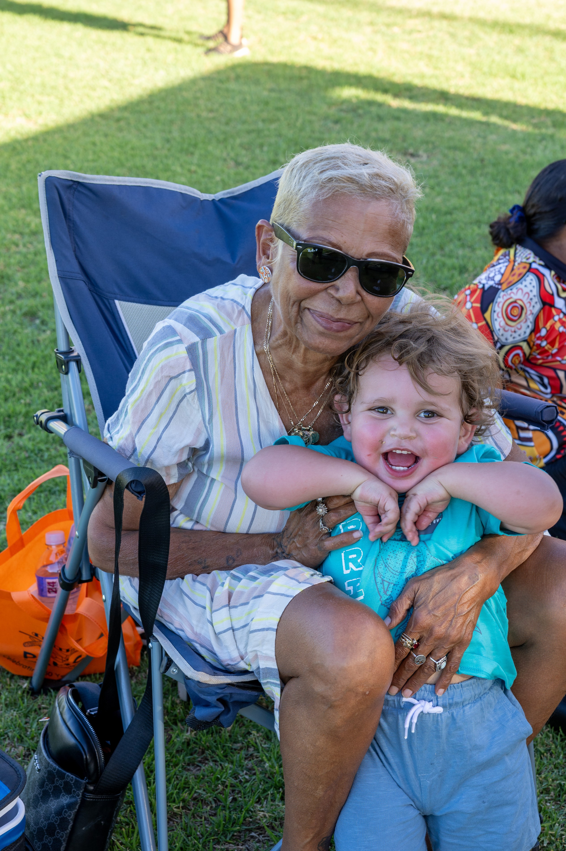
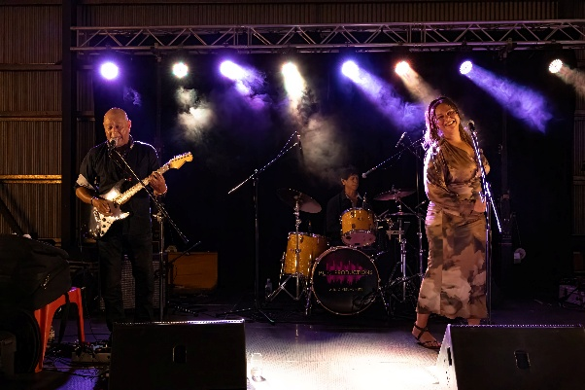



Community Health Programs and Family Health Team
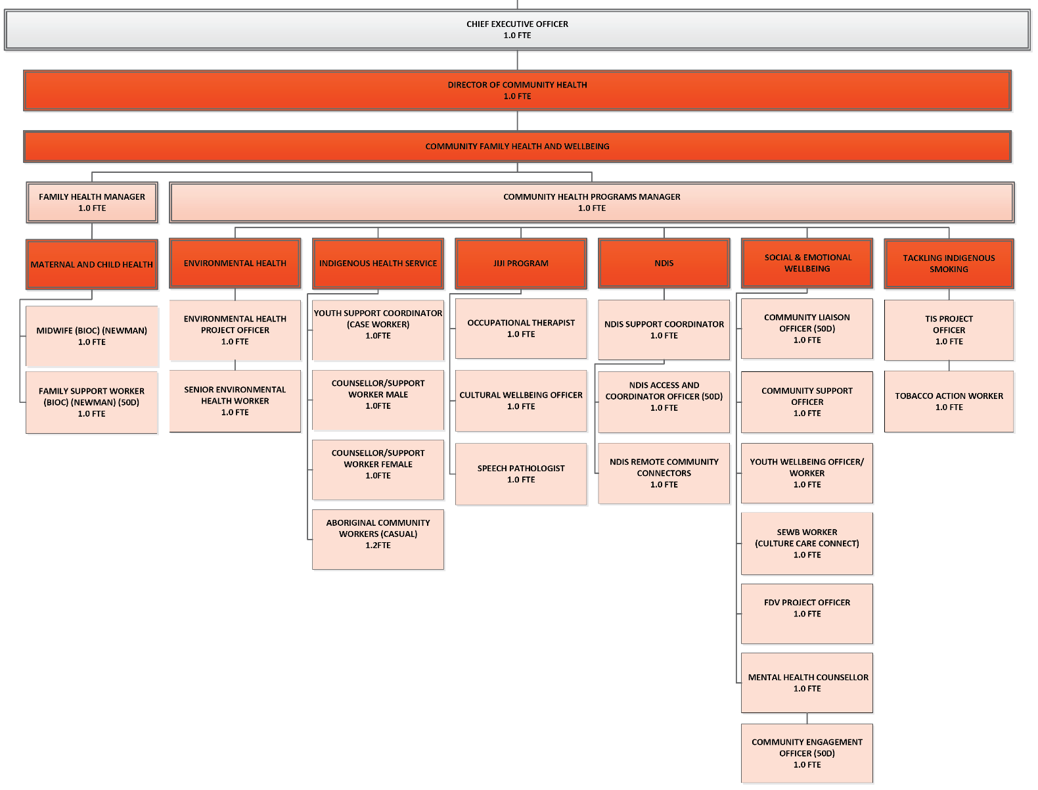
PAMS Community Health and Programs Team is dedicated to supporting the health and wellbeing of Aboriginal people across the East Pilbara. The team delivers a wide range of culturally safe programs designed to meet the needs of individuals, families, and communities through health promotion, early intervention, and tailored support services.
Punkuturnu Aboriginal Medical Service Board of Directors
Community Family Health and Wellbeing
De-Identified
Board Endorsed 19/06/25

The programs span several key areas, including:

Health Programs
- Environmental Health (EH)
- NDIS (Self-Funded and RCC)
- Beyond Mental Health (NIAA)
- Community Liaison Officers / Mental Health Commission (CLO / MHC)
- Aftercare Services (CCC)
- Youth Wellbeing Officer (YWO – BHP)
- Social and Emotional Wellbeing (SEWB – WAPHA)
- Tackling Indigenous Smoking (TIS)
- Jiji Programs
- PATS Journey – Footprints to Better Health Primary Health Care
- Family Domestic and Sexual Violence (FDSV – AHCWA)
- Martu STI Response
- Indigenous Healing Services – Safe Spaces
- Emergency Relief (BHP & AHCWA/Lotterywest)

Family Health / Upstream Programs
- Baby Coming You Ready (Paul Ramsay Foundation)
- Fetal Alcohol Spectrum Disorder (FASD – NACCHO)
- Upstream Phase 2 (BHP / Telethon Kids Institute)

Location:
The team operates from the Newman Hub, co-located with the Newman Clinic and Dialysis Centre.

Opening Hours:
Monday to Friday – 8:30 AM to 5:00 PM

Contact Details:
Phone: 08 9177 8307
Fax: 08 9175 0990
Email: pams@puntukurnu.com

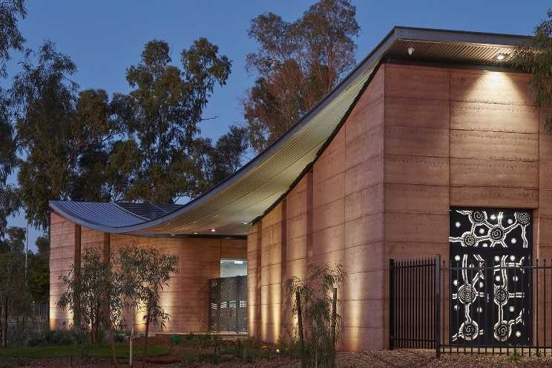
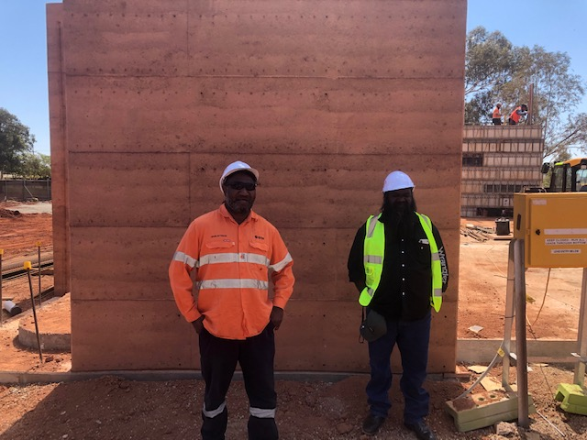
Newman Clinic and Administration Building
Left to right – Irwin Attwood (Former Director for Punmu Community) and PAMS Chairperson Melvin Farmer viewing the progress of the Newman Clinic build

Remote Clinics Overview: Jigalong, Parnngurr, Punmu & Kunawarritji
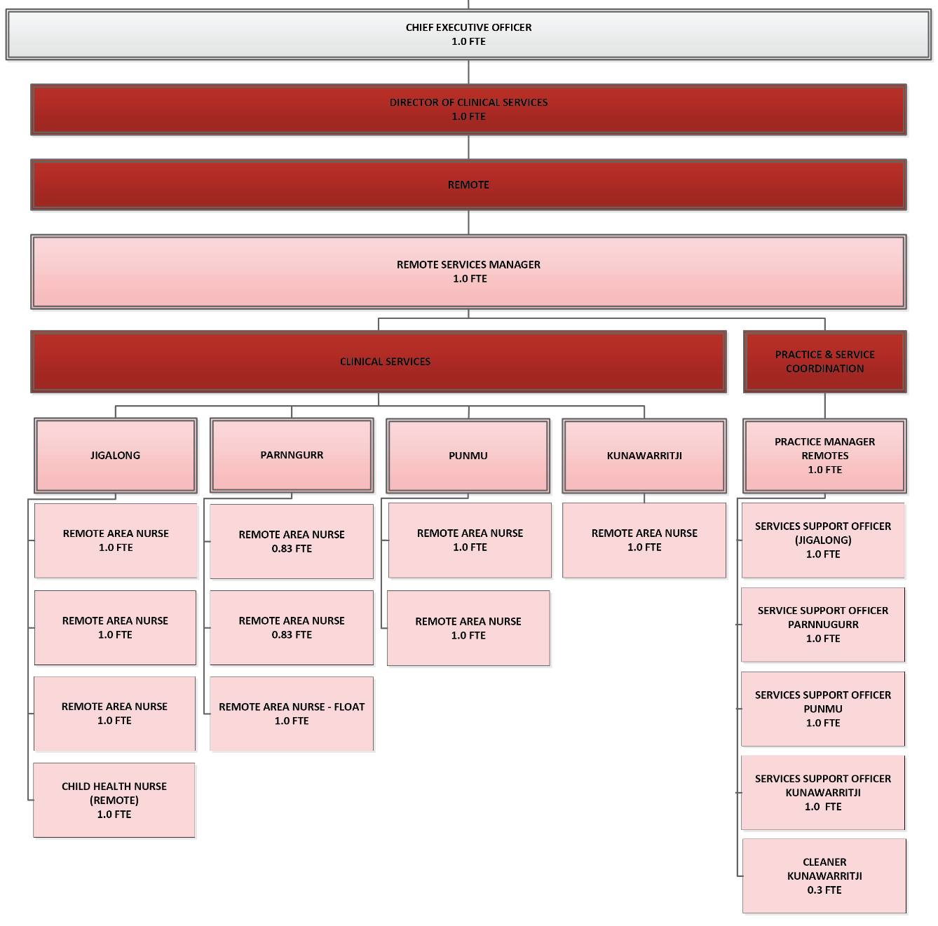
The following sections provides essential information on PAMS’ four remote clinic locations, helping staff understand the clinical, cultural, and logistical environment of each community. Whether you are visiting for a short placement or supporting services remotely, this guide ensures respectful, safe, and informed engagement.
Clinical Services Remote
De-Identified
Board Endorsed 19/06/25
Punkuturnu Aboriginal Medical Service Board of Directors

Each clinic profile outlines:

Clinic Facilities & Services
Details of the clinical setup, including consulting rooms, emergency capacity, treatment spaces, and any specialist features.

Opening Hours & Contacts
Standard operating hours and key contact numbers and emails for each clinic.

Travel, Permits & Mail Plane
Travel time from Newman, road conditions, whether permits are required, and how mail and supplies are delivered.

Staffing & Vehicles
Who is based at each clinic, staffing levels (single or double nurse posts), and the vehicles available for use on site.

Accommodation
Overview of staff housing — layout, furnishings, amenities — and what to expect when living in community.

Community Services
Local infrastructure such as fuel stations, schools, stores, and recreation facilities.

Cultural Protocols: No Go Areas & Lore Grounds
Each community contains sacred cultural sites — often referred to as No Go Areas — that must be respected at all times. These include areas used for Men’s and Women’s Lore, which may be off-limits seasonally or permanently. Staff must observe signage, seek local guidance if unsure, and avoid entering these areas. Understanding and respecting these protocols is vital to working safely and appropriately within Martu communities.
This section is critical for preparing staff to work respectfully in Martu Country and ensures your presence in community aligns with cultural obligations and expectations.

Jigalong Clinic

General
The Jigalong Clinic has 4 consulting rooms. Space for visiting Consulting Staff.

Opening Hours:
9:00 to 12:00 and 13:00 to 16:30 Monday, Wednesday, Thursday and Friday
9:00 to 12:00 Tuesday

Contact Details:
Phone: 08 9175 7027 Mobile 1: 0476 834 161 Mobile 2: 0476 835 239
Email: jigalong.reception@puntukurnu.com

Permits
A Permit approval is required before entering into Jigalong Community, this will be done by the Practice Manager – Remote Clinics.

Travelling to Jigalong
The driving distance from Newman to Jigalong is 165kms on dirt road, estimated 2 hours drive.
Staff travelling to and from Jigalong are usually transported via road.

Mail plane to Jigalong
The Mail Plane comes to Jigalong every Thursday. One week it lands around 7.30am the second week it lands around 1.30-2.30pm. We receive our Mail and freight this includes Medication from Newman.
There is the opportunity to have food delivered on the Mail Plane but it does depend on load capacity so not always possible.

Dr’s Charter
PAMS Remote GP who is usually based in Jigalong visits the remote communities of Parnngurr, Punmu and Kunawarritji on a fortnightly basis. We use this flight to send medical requirements to the outer clinics from Jigalong Clinic if there is load capacity.

Vehicles on site
Dr’s Car, Patient Transport and Ambulance

Accommodation
Accommodation is furnished with basic cooking utensils, bedding, washing machines, clothes lines etc. The PAMS accommodation is currently under rebuild. The staff in Jigalong are residing in rented accommodation in the community.

Accommodation in Jigalong
- 5 x 2 Bedroom/1 Bathroom Houses for Nurses & Visitors
- 1 x 2 Bedroom/1 Bathroom Doctors House
- 1 x 3 Bedroom/1 Bathroom House used for Transient/Temporary Accommodation
- 1 x 3 Bedroom/2 Bathroom House used as needed
All PAMS staff accommodation has Foxtel/internet/landlines/air conditioning

Services in the Community:
- Community Office / CEO
- Community Store
- Fuel station
- ATM
- Swimming pool / basketball court
- School (pp-12)
- Police
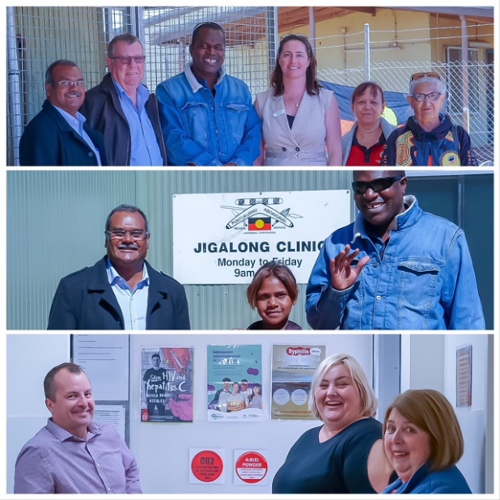
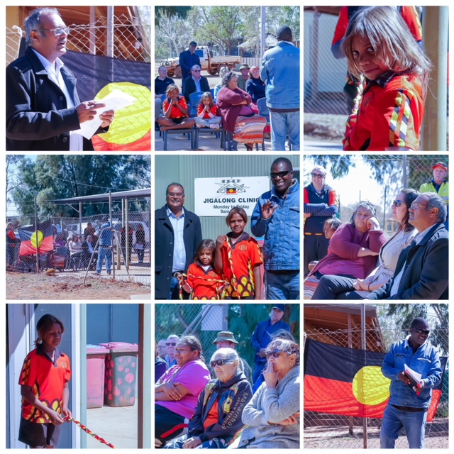
Images from the Official Opening of the newly refurbished Jigalong Clinic in 2019

Map of Jigalong 1
Details of note:
- No Go Area (cultural traditions)
- Clinic #5
- Doctors House #6
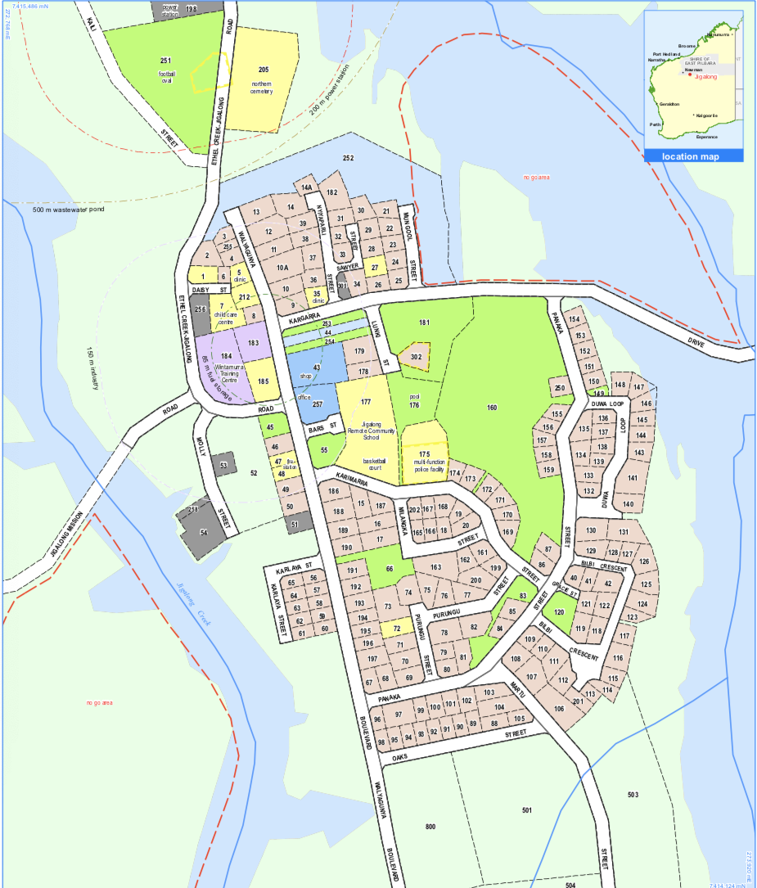
- Other housing #2, #3, #4 and #255

Map of Jigalong 2
Details of note
- No Go Area (cultural traditions)
- Airstrip (Long Yellow area) (RFDS)
No Go Area
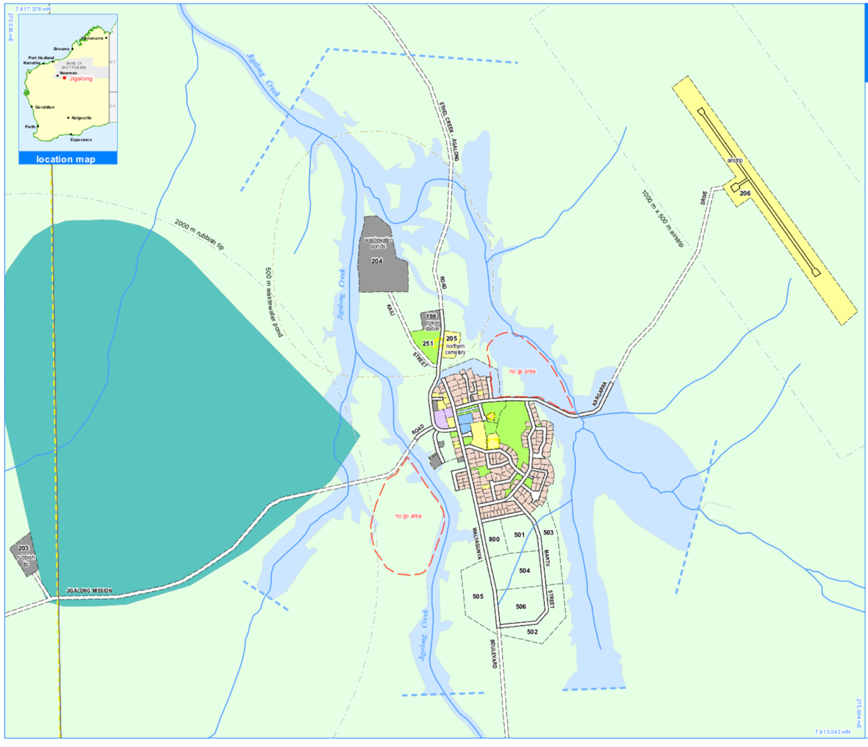
(Department of Planning, 2019)
No Go Area

Parnngurr (also known as Cotton Creek) Clinic

General
The new Parnngurr clinic was opened in 2018, there are two consulting rooms, one fully equipped and one that is used mainly by visiting staff and can be equipped as needed and a Treatment room. There is also a renal self-dialysis room off the waiting room, at the time of writing it is not currently in use. Bathroom/toilet facilities, Pathology room, store room, medication room.

Opening Hours:
9:00 to 12:00 and 13:00 to 16:30 Monday, Wednesday, Thursday and Friday
9:00 to 12:00 Tuesday

Contact Details:
Phone: 08 9176 9057 Mobile: 0431 417 353
Email: parnngurr.clinic@puntukurnu.com

Permits
No formal permit is required prior to entering the community, however it is advisable to visit the Community Office / CEO upon arrival.
Diesel fuel and opal petrol are available during shop hours.

Travelling to Parnngurr
The driving distance from Newman to Parnngurr is 368kms on dirt road, estimated driving time – it is always 4-5 hours, extreme care is to be taken on Tallawana track as it frequently has severe washouts (serious accident to staff in the past on this road).
Staff travelling to and from Parnngurr are usually transported via the mail plane, which is usually around 1 hours flying time.

Mail plane to Parnngurr
Every Thursday morning the mail plane comes into Parnngurr to deliver mail to the community and medication supplies for the clinic
If you require food to be delivered to you from Newman, this will be transported via the mail plane.

Staffing
Parnngurr is a double staffed nursing post

Vehicles
- 1 x Ambulance
- 1 x Patient transport vehicle

Accommodation
Accommodation is furnished with basic cooking utensils, bedding, washing machines, clothes lines etc.

PAMS has the following accommodation in Parnngurr
- 1 x 2 Bedroom/1 Bathroom House for Staff
- 1 x 1 Bedroom/1 Bathroom House for Staff
Telstra Landlines have been down for 12 months at accommodation however data is available
Parnngurr is an Optus community
Store hours are 0800-1100 and 1400-1600 weekdays and 0800-1100 Saturdays
All PAMS staff accommodation has Foxtel/internet/landlines/air conditioning

Services in the Community:
- Community Office / CEO
- Community Store
- Fuel station
- basketball court
- School (pp-12)
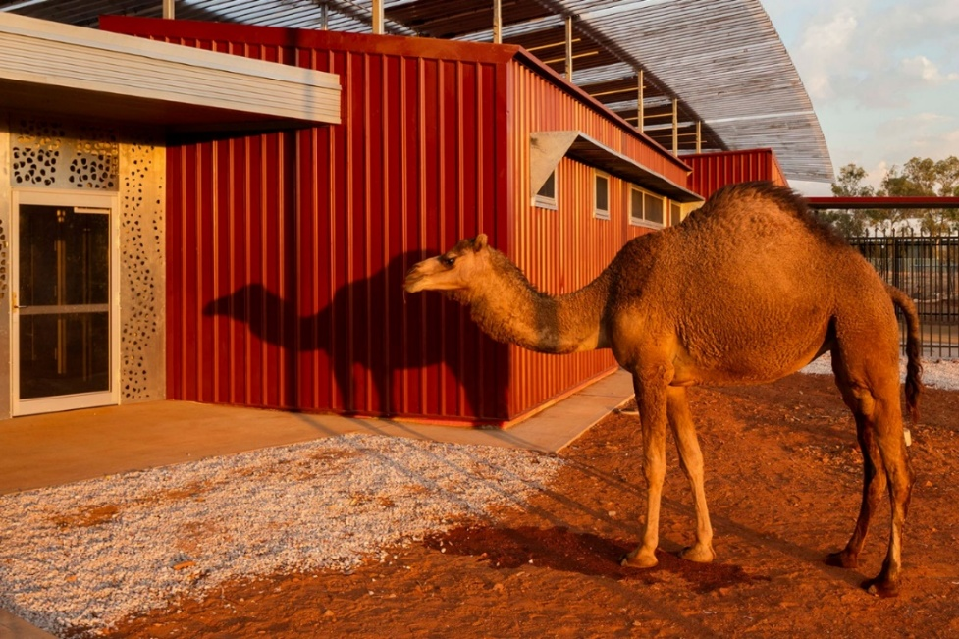
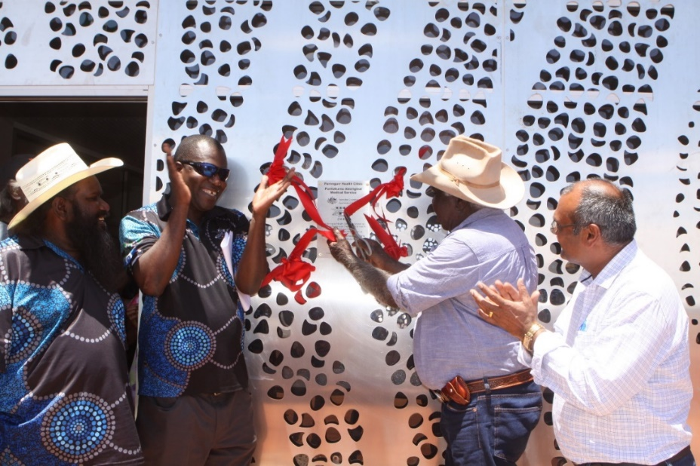
Official Opening of the new Parnngurr Clinic
Left to right – PAMS Chairperson Mr Melvin Farmer, CEO, Mr Robby Chibawe,
Community Elder Mr Jimmy Williams, Member for the Pilbara Mr Kevin Michel

Map of Parnngurr 1
Details of note
- No Go Area (cultural traditions)
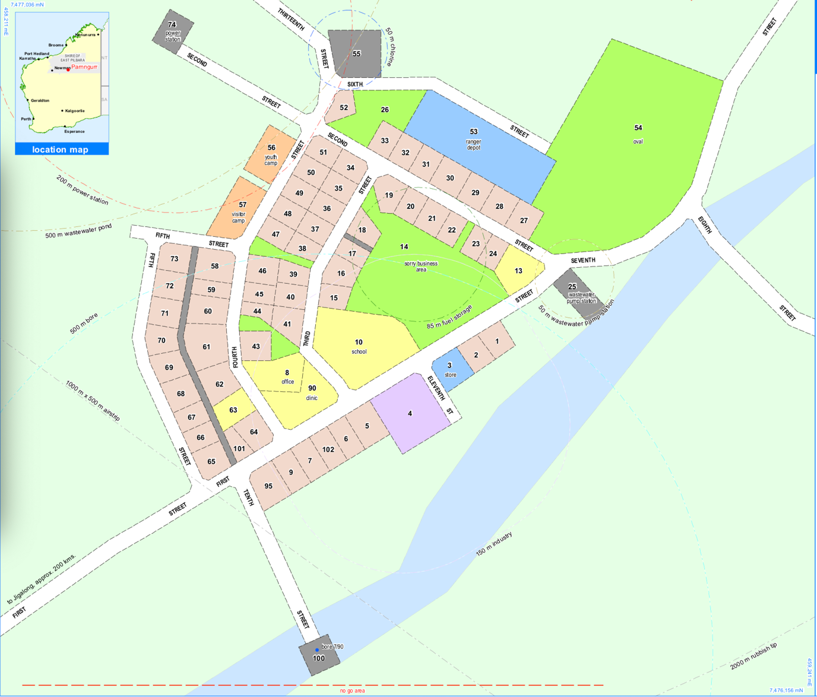
- Clinic
No Go Area
(Department of Planning, 2019)

Map of Parnngurr 2
Details of note
- No Go Area (cultural traditions)
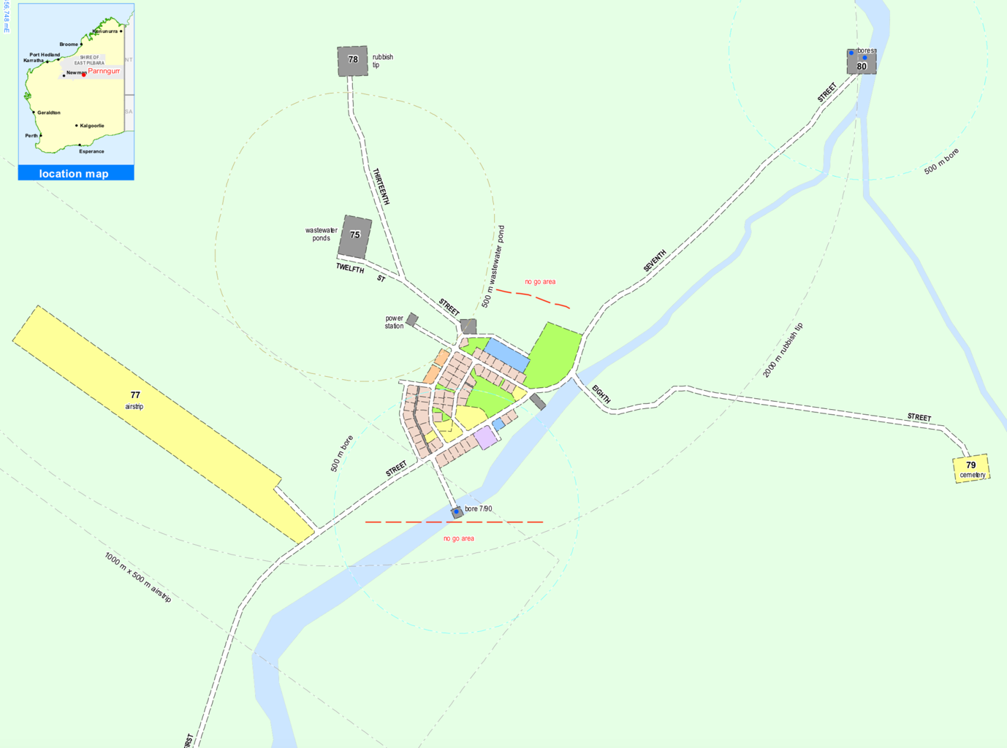
- Airstrip yellow (RFDS)
No Go Area
(Department of Planning, 2019)
No Go Area

Punmu Clinic

General
The new Punmu clinic was opened in 2018, there are two Consulting rooms, one fully equipped and one that is used mainly by visiting staff and can be equipped as needed and a Treatment room. There is also a renal self-dialysis room off the waiting room, at the time of writing it is not currently in use. Bathroom/toilet facilities, Pathology room, storeroom, medication room.

Opening Hours:
9:00 to 12:00 and 13:00 to 16:30 Monday, Wednesday, Thursday and Friday
9:00 to 12:00 Tuesday

Contact Details:
Phone: 08 9176 9013 Mobile: 0423 956 082
Email: punmu.clinic@puntukurnu.com

Permits
No formal permit is required prior to entering the community, however it is advisable to visit the Community Office / CEO upon arrival.

Travelling to Punmu
The driving distance from Newman to Jigalong is 944kms on dirt road, with an estimated 8 hours driving time
Staff travelling to and from Punmu are usually transported via the mail plane

Mail plane to Punmu
Every Thursday mid-morning to early afternoon, the mail plane comes into to Parnngurr to deliver mail to the community and medication supplies for the clinic
If you require food to be delivered to you from Newman, this will be transported via the mail plane.

Staffing
Punmu is a double-staffed nursing post with a casual Administration Officer. At various times additional staff are located at Punmu particularly during Lore and sports carnivals.

Vehicles
- 1 x Ambulance
- 1 x Patient transport vehicle

Accommodation
Accommodation is furnished with basic cooking utensils, bedding, washing machines, clothes lines etc.

PAMS has the following accommodation in Punmu
- 1 x 3 Bedroom/2 Bathroom House for Nurses
- 1 x 2 Bedroom/1 Bathroom House for a Nurse
- 1 x 3 Bedroom/1 Bathroom House for a Doctor
All PAMS staff accommodation has Foxtel/internet/landlines/air conditioning

Services in the Community:
- Community Office / CEO
- Community Store
- Fuel station
- basketball court
- School (pp-12)
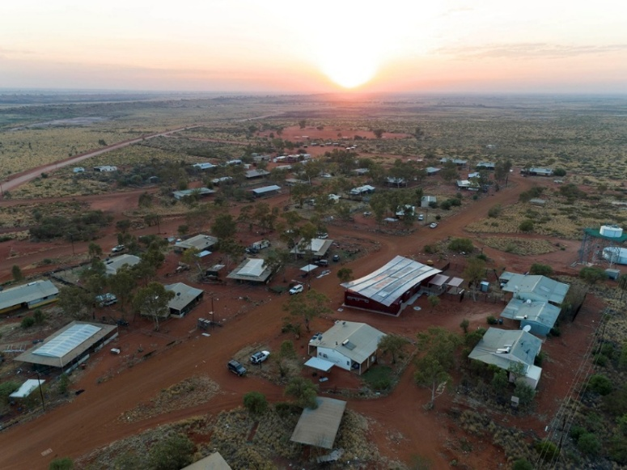
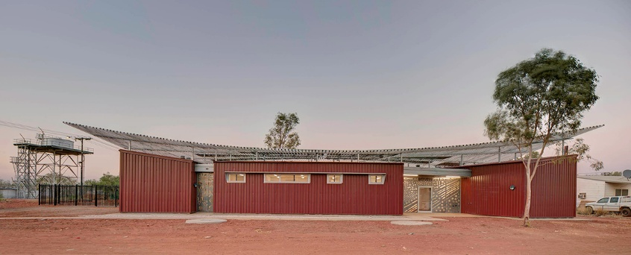

Map of Punmu 1
Details of note:
- No Go Area (cultural traditions)
- Clinic
- Secret Men’s Business/ Lore grounds is located on the left hand side of the road driving out of the community to the turn off to Port Hedland.
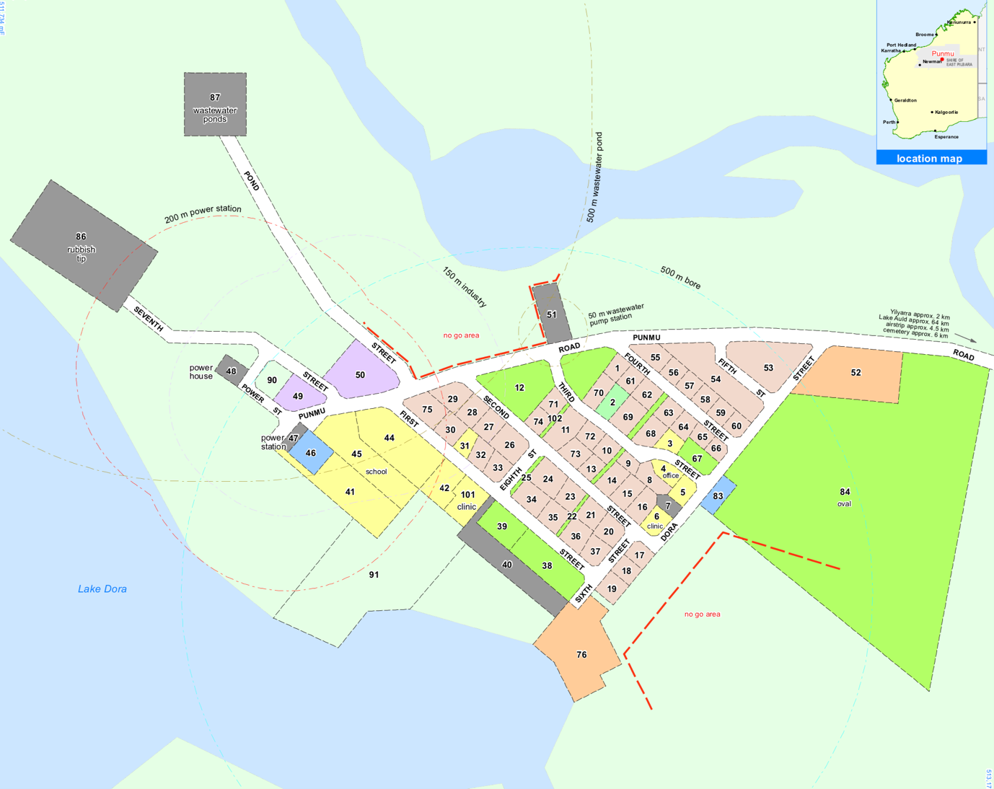
- Secret Women’s Business / Lore grounds is located on the right hand side of the football oval facing the airstrip.
(Department of Planning, 2019)
No Go Area
No Go Area

Map of Punmu 2
Details of note:
- No Go Area (cultural traditions)
- Airstrip (RFDS)
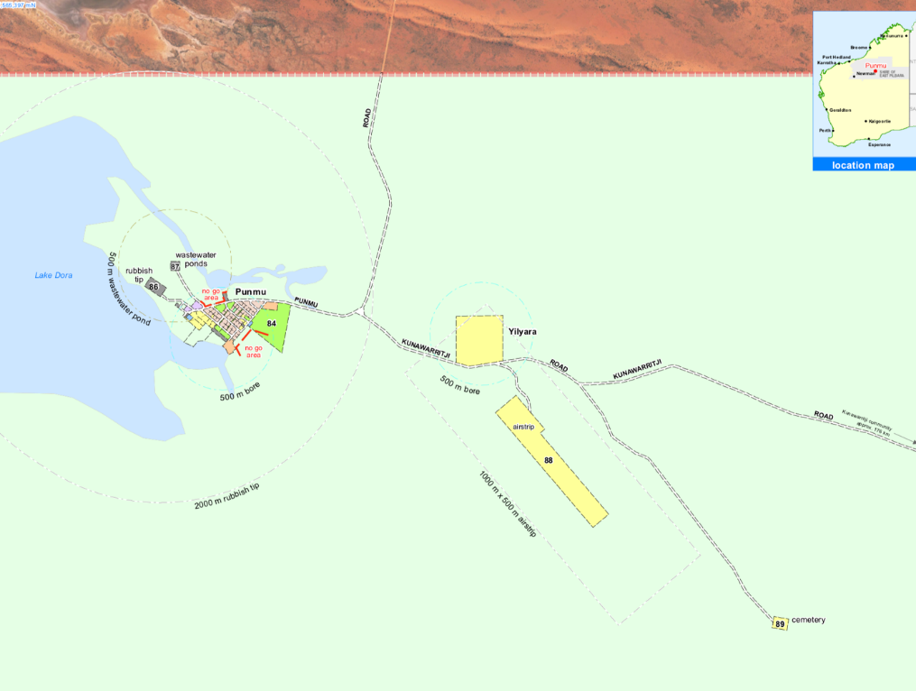
(Department of Planning, 2019)

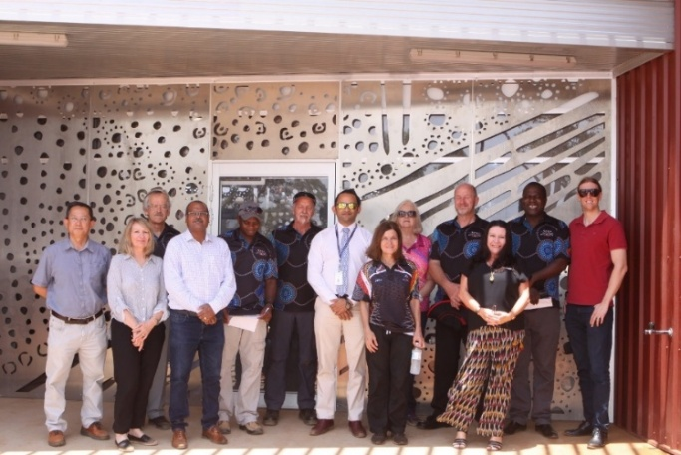
Official Opening of the new Punmu Clinic – attended by WACHS, WAPHA, PAMS Directors, PAMS CEO, PAMS Staff, Shire of East Pilbara Councillors and Member for the Pilbara

Kunawarritji (also known as Well 33) Clinic

General
The clinic in Kunawarritji was refurbished in 2017 and is reasonably sized for the population. It has an emergency room, a large waiting room, an office/treatment room, bathroom, small tea-room and a medication room.

Opening Hours:
9:00 to 12:00 and 13:00 to 16:30 Monday, Wednesday, Thursday and Friday
9:00 to 12:00 Tuesday

Contact Details:
Phone: 08 9176 9041 Mobile: 0412 112 014
Email: kunawarritji.clinic@puntukurnu.com

Permits
No formal permit is required prior to entering the community, however it is advisable to visit the Community Office / CEO upon arrival.

Travelling to Kunawarritji
The driving distance from Newman to Kunawarritji is 1250kms on dirt road, estimated 12 hours driving time. Staff travelling to and from Kunawarritji are usually transported via the mail plane

Mail plane to Jigalong
Every Thursday afternoon the mail plane comes into to Kunawarritji to deliver mail to the community and medication supplies for the clinic. If you require food to be delivered to you from Newman, this will be transported via the mail plane.

Staffing
Kunawarritji clinic is a single-staffed nursing post.

Vehicles
- 1 x Ambulance
- 1 x Patient Transport vehicle

Accommodation
Accommodation is furnished with basic cooking utensils, bedding, washing machines, clothes lines etc.

PAMS has the following accommodation in Kunawarritji
- 1 x 3 Bedroom/1Bathroom House for Staff
- 4 x Donga’s with a Bed & Bathroom
All PAMS staff accommodation has Foxtel/internet/landlines/air conditioning

Services in the Community:
- Community Office / CEO
- Community Store
- Fuel station
- basketball court
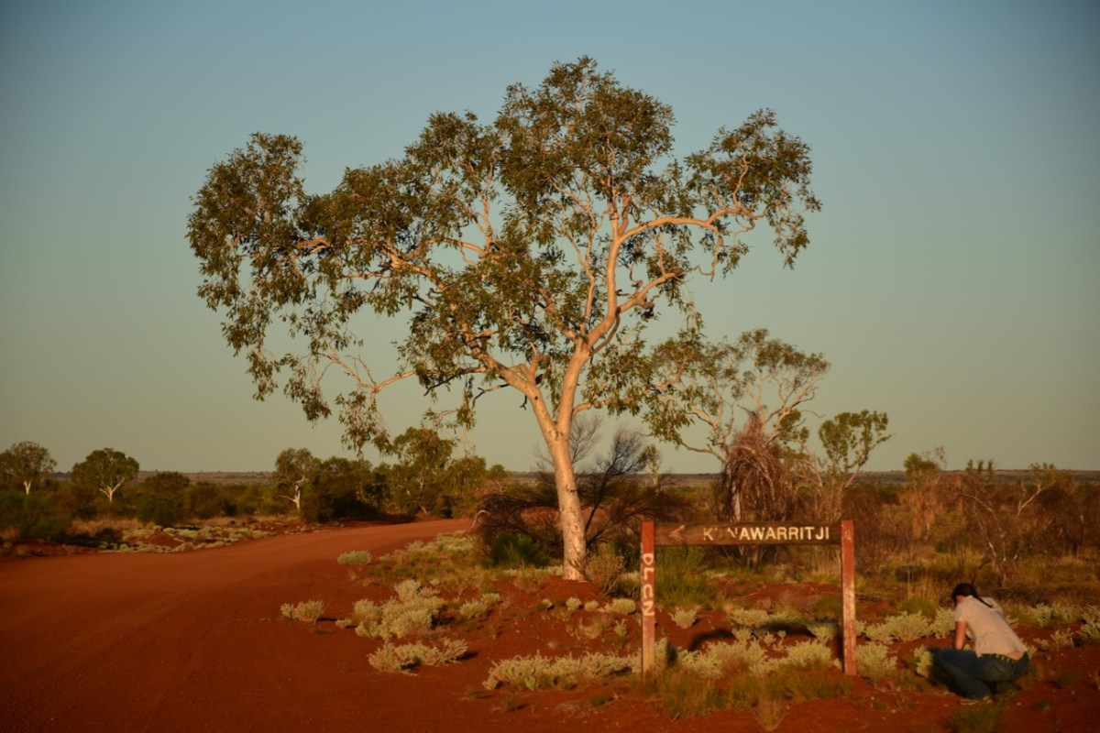
- School (pp-12)

Map of Kunawarritji 1
Details of note
- No Go Area (cultural traditions)
- #1 Nurses House--
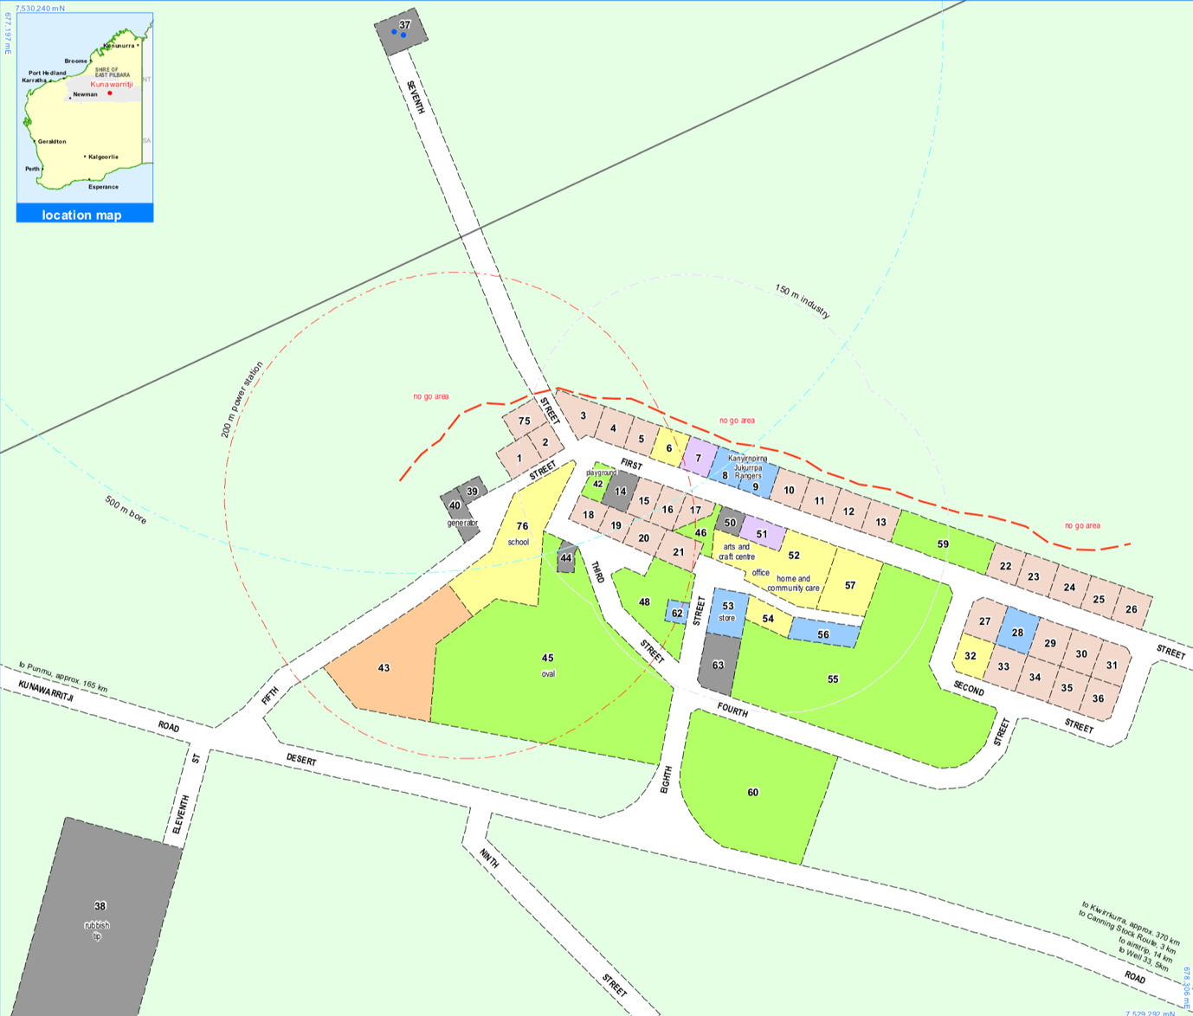
- Clinic #
(Department of Planning, 2019)
No Go Area

Map of Kunawarritji 2
Details of note:
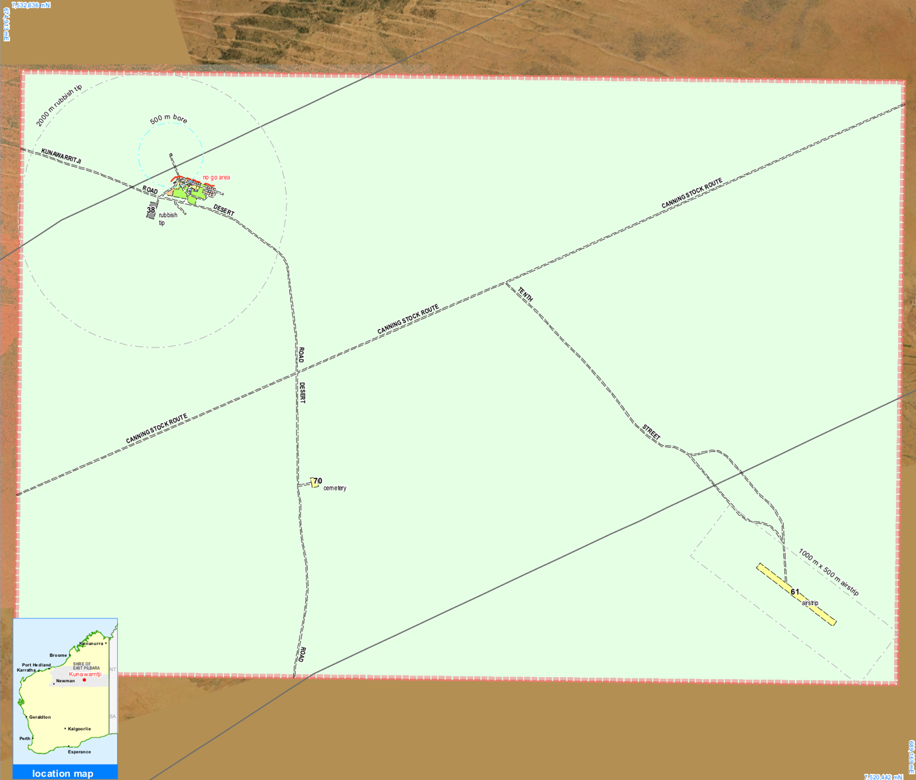
- Airstrip (RFDS) Yellow stripe

Contact Us:
pamshr@puntukurnu.com

